MSc Data Science Project

7PAM2002-0509-2023

Department of Physics, Astronomy and Mathematics

**Data Science FINAL PROJECT REPORT**

**Project Title:**

Medical Insurance Cost Prediction

**Student Name and SRN:**

Shubham Verma 22099668 (sv23abk@herts.ac.uk)

Supervisor: Dr Man Lai Tang

Date Submitted: 27th Aug 2024

Word Count: 7085

DECLARATION STATEMENT

This report is submitted in partial fulfilment of the requirement for the degree of Master of Science in Data Science at the University of Hertfordshire.

I have read the guidance to students on academic integrity, misconduct and plagiarism information at [Assessment Offences and Academic Misconduct](https://www.herts.ac.uk/__data/assets/pdf_file/0007/237625/AS14-Apx3-Academic-Misconduct-v17.0.pdf) and understand the University process of dealing with suspected cases of academic misconduct and the possible penalties, which could include failing the project module or course.

I certify that the work submitted is my own and that any material derived or quoted from published or unpublished work of other persons has been duly acknowledged. (Ref. UPR AS/C/6.1, section 7 and UPR AS/C/5, section 3.6). I have not used ChatGPT, or any other generative AI tool, to write the reportor code (other than where declared or referenced).

I did not use human participants or undertake a survey in my MSc Project.

I hereby give permission for the report to be made available on module websites provided the source is acknowledged.

Student Name printed: ***Shubham Verma***

Student Name signature: 

Student SRN number: ***22099668***

UNIVERSITY OF HERTFORDSHIRE

SCHOOL OF PHYSICS, ENGINEERING AND COMPUTER SCIENCE

***Acknowledgments***

I would like to express my deepest gratitude to Dr. Carolyn Devereux, my Program Leader, for her unwavering guidance and encouragement throughout this journey. Her insightful advice and dedication have been instrumental in shaping my academic path.

A special thank you to my Supervisor, Dr. Man Lai Tang, whose expertise and thoughtful feedback have been invaluable in the development of this project. Her support and constructive criticism pushed me to achieve a higher level of academic rigor.

I am also profoundly grateful to the University of Hertfordshire for providing an enriching learning environment and the resources necessary to pursue this research. The knowledge and experiences I have gained here will continue to guide me in my future endeavours.

Lastly, I would like to extend my heartfelt thanks to my parents, my sister, and my friends. Their constant love, support, and belief in me have been my greatest source of strength. This achievement would not have been possible without them.

***Abstract***

This MSc Data Science project focuses on developing accurate models to predict medical insurance costs, a crucial issue for both individuals and insurers. The study examines the impact of demographic, behavioural, and geographical factors, including age, sex, BMI, number of dependents, smoking status, and region, on insurance costs. Using linear regression, quantile regression, and XGBoost, the project assesses and compares the effectiveness of these models under various conditions, including feature selection and the removal of outliers. The analysis reveals the limitations of traditional regression methods and highlights the superior performance of XGBoost in capturing the complexity and variability of medical costs. The findings contribute to the development of more reliable predictive models, offering significant implications for risk management and pricing strategies in the insurance industry. This work provides a foundation for further research and practical applications in improving healthcare cost predictions.

Contents

1. Introduction 7

1.1 Research Questions, Aims, and Objectives 7

1.1.1 Research Questions 7

1.1.2 Aims and Objectives: 8

2. Literature Review 10

2.1 Background 10

2.2 Linear Regression 11

2.3 Quantile Regression 12

2.4 Comparison of Linear and Quantile Regression 14

3. Methodology 15

3.1 Brief Overview 15

3.2 Dataset Used 15

3.3 Data Ethics 16

*3.3.1* *Anonymization and Personal Data* 16

*3.3.2* *GDPR Compliance* 17

*3.3.3* *UH Ethical Approval* 17

*3.3.4* *Permission and Licensing* 17

*3.3.5* *Ethical Data Collection* 17

3.4 Data Preprocessing 18

*3.4.1* *Feature Extraction and Data Transformation* 18

3.5 Regression Models 19

*3.5.1* *Linear Regression* 19

*3.5.2* *Polynomial Regression* 21

*3.5.3* *Ridge Regression* 21

*3.5.4* *Lasso Regression* 21

*3.5.5* *Quantile Regression* 22

*3.5.6* *XGBoost* 22

3.6 Summary 23

4. Results and analysis 24

4.1 Exploratory Data Analysis (EDA) 24

*4.1.1* *Right-Skewed Distribution of Charges* 24

*4.1.2* *Impact of Smoking on Medical Charges* 25

*4.1.3* *Age and Medical Charges* 25

*4.1.4* *Interaction Between BMI, Smoking, and Medical Charges* 26

*4.1.5* *Cluster Analysis in Age vs. Charges* 27

4.2 Linear Regression 28

*4.2.1* *Original Data* 28

*4.2.2* *Data After Removing High Leverage Points and Outliers* 28

*4.2.3* *After Feature Selection* 28

*4.2.4* *After Feature Selection and Removing Outliers* 29

4.3 Quantile Regression 29

*4.3.1* *Original Data* 30

*4.3.2* *Data After Removing High Leverage Points and Outliers* 30

*4.3.3* *After Feature Selection* 30

*4.3.4* *After Feature Selection and Removing Outliers* 31

4.4 XGBoost 31

*4.4.1* *XGBoost with Linear Regression* 31

4.4.1.1 Original Data 31

4.4.1.2 Data After Removing High Leverage Points and Outliers 32

4.4.1.3 After Feature Selection 32

4.4.1.4 After Feature Selection and Removing Outliers 32

*4.4.2* *XGBoost with Quantile Regression* 33

4.4.2.1 Original Data 33

4.4.2.2 Data After Removing High Leverage Points and Outliers 33

4.4.2.3 After Feature Selection 33

4.4.2.4 After Feature Selection and Removing Outliers 34

4.5 Comparing Linear Regression and Quantile Regression at 0.5 Quantile 34

*4.5.1* *Original Data* 34

*4.5.2* *Data After Removing High Leverage Points and Outliers* 35

*4.5.3* *After Feature Selection* 35

*4.5.4* *After Feature Selection and Removing Outliers* 35

4.6 Conclusion 36

5. Discussion 37

5.1 Limitations 37

5.2 Improvements and Future Scope 37

*5.2.1* *Interpretation of Results* 37

*5.2.2* *Comparison to Literature* 38

5.2.3 Limitations of Results 38

5.2.4 Relation to Project Objectives 38

5.2.5 Practical Use of Models 39

5.2.6 Answering the Research Questions 39

6. Conclusion 41

7. References 42

8. Appendices 43

# Introduction

The rising cost of health care is a major problem worldwide for both the individual and the insurance provider. The cost of medical insurance needs to be predicted with high accuracy since it forms a basis for managing financial risk and ensuring the sustainability of health care systems. For individuals, unpredicted high medical costs often cause extreme financial stress, while for insurance companies, bad estimates of costs can disrupt their risk management strategies and lead to huge losses (Kaushik et al., 2022).

Therefore, the aim of this project is to come up with a reliable predictive model in estimating medical insurance costs according to diverse demographic, behavioural, and geographical variables such as age, sex, BMI, number of dependents, smoker or not, and region of residence. In fact, such variables influence the cost of insurance both in their direct capacity and in interaction with other factors in very complicated ways (Panda et al., 2022).

At present in the insurance industry, traditional linear regression models are commonly being used for the prediction of cost. This is because they are simple and interpretable. However, these models often fail to capture the nuances in the data, particularly the variability at different points in the cost distribution. However, this project goes a step further than those traditional methods by examining the effectiveness of more advanced techniques, such as quantile regression and XGBoost, in helping to model more accurately.

## Research Questions, Aims, and Objectives

### Research Questions

How can the hidden patterns and behaviours in the medical cost dataset be uncovered?

What are the effects of variable selection, interaction effects, and multicollinearity on the performance of regression models?

How does quantile regression compare to traditional regression techniques in predicting medical insurance costs?

### Aims and Objectives:

***Aim 1:*** To uncover hidden patterns within the medical cost data.

Objective 1.1: Perform exploratory data analysis to identify key trends and anomalies.

Objective 1.2: Apply clustering techniques to detect patterns that may influence cost predictions.

***Aim 2:*** To analyse the impact of variable selection, interaction effects, and multicollinearity on regression models.

Objective 2.1: Employ feature selection methods to identify the most significant predictors.

Objective 2.2: Assess the impact of multicollinearity and interaction effects on model performance.

***Aim 3:*** To compare the performance and applicability of quantile regression versus traditional regression methods.

Objective 3.1: Implement and evaluate linear regression, quantile regression, and XGBoost models.

Objective 3.2: Compare model performance across different data scenarios, including the handling of outliers and feature selection.

In summary, this project is positioned to provide a comprehensive evaluation of advanced modelling techniques in the context of medical insurance cost prediction. By addressing the limitations of traditional approaches and incorporating cutting-edge methods, this study aims to enhance predictive accuracy, offering valuable insights for the insurance industry in its ongoing efforts to manage healthcare-related financial risks.

# Literature Review

Medical cost prediction probably stands in the forefront of all research work areas in healthcare compared with services, the complexity and costliness of which have been rising. Precise health cost prediction is of prime importance to insurance companies, healthcare providers, and policymakers for risk evaluation, efficient resource management, and design of appropriate pricing strategy. In that arena, the literature is huge, developing from basic linear models to very complicated machine learning algorithms only over the last decade. Below follow several novel research methods and approaches that, in time, have been used for medical insurance expenditure prediction: starting from linear regression to quantile regression and its recent developments under machine learning methodologies, including XGBoost. It then identifies the importance of feature selection and how high leverage points and outliers can be managed (Zou et al., 2023).



## Background

Predicting medical costs is crucial for insurance companies, healthcare providers, and policymakers, as it informs risk assessment, pricing strategies, and resource allocation. Traditionally, Linear Regression has been widely used due to its simplicity and interpretability, modelling the relationship between medical costs and predictors like age, BMI, and smoking status. However, Linear Regression assumes a linear relationship and struggles with non-linear patterns, skewed distributions, and outliers commonly found in healthcare data.

To address these limitations, Quantile Regression has emerged as a more robust alternative. Unlike Linear Regression, which estimates the mean of the dependent variable, Quantile Regression provides insights across different points in the distribution, such as the median or other quantiles. This approach is particularly valuable in healthcare cost prediction, where the impact of factors like smoking or BMI can vary significantly between low-cost and high-cost patients. Quantile Regression better captures this variability, making it a more suitable method for analysing complex, skewed data (Staffa et al., 2019).

Recent advancements in machine learning, such as XGBoost, have further expanded the toolkit for medical cost prediction, offering powerful non-linear modelling capabilities. However, these methods often come with challenges related to interpretability and require careful tuning and validation (Tufail et al., 2023).

This literature review examines key studies that have applied and compared Linear Regression and Quantile Regression in predicting medical costs, providing a foundation for understanding the strengths and limitations of each approach in healthcare analytics.

## Linear Regression

A statistical method to model the linear relationship between a dependent variable and one or more independent variables.

**Newhouse, J. P. (1992). Medical Care Costs: How Much Welfare Loss?**

***Summary:*** Newhouse's (1992) work is a seminal paper that laid the foundation for using Linear Regression in medical cost prediction. The study demonstrated that demographic variables such as age, sex, and income were significant predictors of healthcare costs. Newhouse's application of Linear Regression provided a straightforward method to estimate medical expenditures, making it one of the earliest and most cited approaches in the literature. Despite the simplicity of the model, the paper highlighted how well linear relationships could capture the influence of demographic factors on medical costs, making it a benchmark for subsequent studies.

**DeMaris, A. (2004). Regression with Social Data: Modeling Continuous and Limited Response Variables.**

***Summary:*** DeMaris (2004) provides a comprehensive overview of regression techniques, with a particular focus on their application in social sciences, including healthcare. This book critically examines the limitations of Linear Regression, particularly its assumption of linearity and its sensitivity to outliers. DeMaris emphasizes the importance of verifying model assumptions and the potential pitfalls when these assumptions do not hold, which is often the case with skewed medical cost data. This work is crucial for understanding the limitations of Linear Regression in more complex datasets, underscoring the need for alternative models in medical cost prediction.

**Dodd, S. (2006).** **A comparison of multivariable regression models to analyse cost data.**

***Summary:*** Dodd et al. (2006) conducted a comparative study of various regression models for predicting health costs, including Linear Regression. The study highlighted that while Linear Regression is useful for its simplicity and interpretability, it often fails in datasets characterized by high variance and non-linear relationships. The authors pointed out that Linear Regression tends to underestimate the cost predictions in cases with extreme values, leading to the exploration of more advanced models that can handle such complexities. This paper is significant as it provides empirical evidence of the limitations of Linear Regression in real-world healthcare data.

## Quantile Regression

A statistical method to model the conditional quantiles of a dependent variable based on one or more independent variables.

**Koenker, R., & Bassett, G. (1978). Regression Quantiles. Econometrica**

***Summary:*** Koenker and Bassett (1978) introduced Quantile Regression, a method that goes beyond the limitations of Linear Regression by modelling different points in the distribution of the dependent variable. This technique is particularly useful in the context of medical cost prediction, where costs are often skewed and include outliers. Quantile Regression allows for a more detailed analysis by estimating the effects of predictors not just on the mean but across the entire distribution of costs. This approach is critical for understanding the variability in medical costs, especially for high-cost individuals who significantly impact the healthcare system.

**Buntin, M. B., & Zaslavsky, A. M. (2004). Too Much Ado about Two-Part Models and Transformation? Comparing Methods of Modeling Health Care Costs. Journal of Health Economics**

***Summary:*** Buntin and Zaslavsky (2004) applied Quantile Regression to medical cost data, emphasizing its advantages over traditional regression methods. The study showed that Quantile Regression provides a more accurate understanding of how different predictors, such as age and smoking status, influence healthcare costs across various quantiles. The authors argued that this method is particularly effective for capturing the dynamics of high-cost patients, which are often masked in mean-based models like Linear Regression. This paper is pivotal in demonstrating the practical application of Quantile Regression in healthcare economics.

**Yu, K., & Moyeed, R. A. (2001). Bayesian Quantile Regression. Statistics & Probability Letters**

***Summary:*** Yu and Moyeed (2001) explored the use of Bayesian methods in Quantile Regression, enhancing the model's robustness in the presence of outliers and skewed distributions. Their approach integrates prior information, which can be particularly useful in medical cost prediction where prior distributions of costs can be informative. The Bayesian Quantile Regression model offers an alternative to frequentist methods, providing more reliable estimates when dealing with extreme values and offering greater flexibility in model specification. This paper contributes to the growing body of literature advocating for more sophisticated methods in medical cost prediction.

## Comparison of Linear and Quantile Regression

Linear Regression remains a fundamental tool in the prediction of medical costs due to its straightforward nature and ease of interpretation. However, as highlighted by Newhouse (1977), DeMaris (2004), and Dodd et al. (2006), its utility is limited by its assumptions of linearity and constant variance. These assumptions often do not hold in real-world medical datasets, which are characterized by skewed distributions and the presence of outliers. Linear Regression tends to provide biased estimates in such cases, especially when predicting costs for individuals with extremely high or low healthcare expenditures.

In contrast, Quantile Regression, introduced by Koenker and Bassett (1978), offers a more flexible and robust alternative. By estimating the conditional quantiles of the response variable, Quantile Regression allows for a more nuanced understanding of how predictors influence different parts of the cost distribution. This is particularly important in healthcare, where the distribution of costs is often highly skewed, and the impact of predictors like age, BMI, and smoking status varies across different cost levels. Buntin and Zaslavsky (2004) and Yu and Moyeed (2001) demonstrate that Quantile Regression is better suited to capture the heterogeneity in medical costs, providing more accurate predictions for high-cost individuals and offering insights into the distributional effects of key predictors.

Overall, while Linear Regression is valuable for its simplicity and ability to provide a clear baseline for comparison, Quantile Regression offers significant advantages in handling the complexities of medical cost data. The choice of model should be guided by the specific characteristics of the dataset and the research objectives, with Quantile Regression being the preferred choice for datasets with significant skewness and heterogeneity.

# Methodology

The methodology section details the steps and techniques employed in the analysis of medical insurance costs. This section is divided into several parts, including a brief overview, dataset description, data preprocessing techniques, and the various regression models utilized in the study.



## Brief Overview

This study aims to predict medical insurance charges based on a variety of demographic, lifestyle, and health-related factors. The analysis involves the use of multiple regression models to understand the relationships between these factors and the insurance charges, with a special focus on capturing the complexities in the data distribution through quantile regression. The study also compares traditional linear and polynomial regression models with regularized models such as ridge and lasso regression, and advanced machine learning techniques like XGBoost, emphasizing the need for sophisticated methods in handling skewed data distributions, high leverage points, and outliers.

## Dataset Used

The dataset used in this study was obtained from Kaggle and includes 1,338 records, each representing an individual's medical insurance cost along with associated demographic and health-related variables. The dataset comprises the following features:

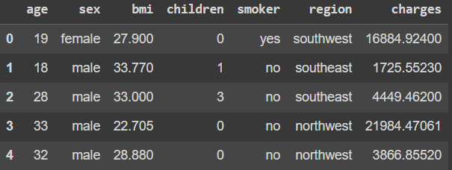

*Fig 1: Sample of dataset*

* ***Age:*** Numerical variable indicating the age of the individual (18–64 years).
* ***Sex:*** Categorical variable representing the gender of the individual ('male' or 'female').
* ***BMI (Body Mass Index):*** Numerical variable calculated as weight in kg divided by the square of height in meters (15–50 range).
* ***Children:*** Numerical variable indicating the number of dependents (0–5).
* ***Smoker:*** Categorical variable indicating whether the individual smokes ('yes' or 'no').
* ***Region:*** Categorical variable indicating the region of residence in the U.S. (northeast, northwest, southeast, southwest).
* ***Charges:*** Numerical variable representing the total medical insurance charges billed to the individual, ranging from $1,000 to $60,000.

This dataset does not contain any missing values, ensuring a robust basis for model training and evaluation.

## Data Ethics

In conducting this study, ethical considerations were carefully evaluated to ensure the responsible use of data. The dataset used for predicting medical insurance costs was sourced from Kaggle, a reputable platform known for providing public datasets for research and educational purposes. The specific dataset can be accessed at https://www.kaggle.com/datasets/mirichoi0218/insurance and is licensed under the Database Contents License (DbCL) v1.0.

### *Anonymization and Personal Data*

The dataset does not contain any directly identifiable personal information such as names, addresses, or social security numbers. Instead, it includes anonymized variables such as age, BMI, smoking status, and region, which are sufficiently generic to prevent the identification of individual participants. This approach aligns with ethical standards and ensures that the data is handled in a manner that protects the privacy of individuals.

### *GDPR Compliance*

Given that the dataset is anonymized and does not involve any directly identifiable personal data, it does not fall under the stringent requirements of the General Data Protection Regulation (GDPR). The data used in this project is thus compliant with data protection regulations, as no personal data subject to GDPR is processed.

### *UH Ethical Approval*

Since the dataset was publicly available and did not involve any active data collection from individuals, University of Hertfordshire (UH) ethical approval was not required. The project did not involve surveys, experiments, or any form of interaction with human subjects, further negating the need for ethical review by the university's ethics committee.

### *Permission and Licensing*

The dataset is freely available for use under the Database Contents License (DbCL) v1.0. This license permits the use, modification, and sharing of the dataset for research and educational purposes, provided that proper attribution is given. There was no need for additional permissions or payments to access or use the data. A screenshot or evidence of the license is maintained as part of the project documentation to ensure transparency and adherence to the licensing terms.



*Fig 2: Licence*

### *Ethical Data Collection*

The data was originally collected by reputable sources, and there is no indication that the data was gathered unethically. The Kaggle platform typically provides datasets that are either crowdsourced or collected from publicly available sources, often for the purpose of advancing research and development in data science. While the dataset does not include details on how the original data was collected, its presence on Kaggle under a clear license suggests that it was shared with the intention of supporting educational and research endeavours in an ethical manner.

In conclusion, the ethical considerations surrounding this dataset have been thoroughly examined, ensuring that the project adheres to ethical standards in data usage, privacy protection, and compliance with licensing requirements. The use of this dataset aligns with best practices in data science, emphasizing the importance of responsible data management throughout the research process.

## Data Preprocessing

Data preprocessing is a critical step in preparing the dataset for effective modelling. It ensures that the data is clean, consistent, and suitable for the regression analysis that follows.

### *Feature Extraction and Data Transformation*

To make the dataset ready for modelling, the following preprocessing steps were undertaken:

* ***Missing Values:*** The dataset was thoroughly checked for missing values, and it was confirmed that no entries were missing.
* ***Categorical Encoding:*** Categorical variables (sex, smoker, and region) were converted into numerical format using one-hot encoding. This process creates binary columns for each category, enabling the regression models to interpret and utilize these variables effectively.
* ***Feature Scaling:*** Numerical features (age, BMI, and charges) were standardized using standard scaling, which adjusts the features to have a mean of 0 and a standard deviation of 1. This step is crucial for models sensitive to the scale of input features, ensuring that all variables contribute equally to the model's predictions.
* ***Log Transformation:*** Given the highly skewed distribution of the charges variable, a log transformation was applied to stabilize the variance and make the distribution more normal. This transformation aids in improving the performance and interpretability of the regression models by reducing the influence of extreme values.
* ***Outlier and High Leverage Point Detection:*** To ensure the robustness of the models, high leverage points and outliers were identified using statistical measures such as Cook's distance and leverage scores. These points, which can disproportionately influence the model, were either removed or adjusted to prevent them from skewing the results.

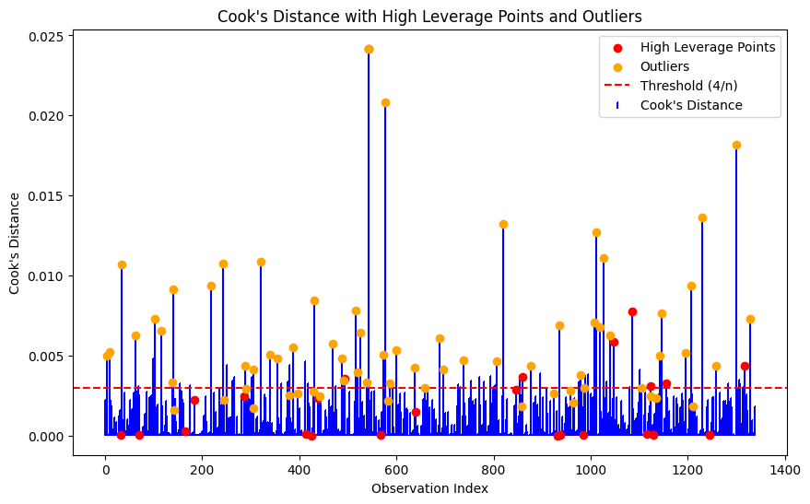

*Fig 3: High leverage points and outliers*

## Regression Models

Various regression models were employed to analyse the relationship between the features and the target variable (charges). These models range from simple linear regression to more complex regularization techniques and advanced machine learning models, each with its specific advantages and applications.

### *Linear Regression*

Linear regression was the first model applied to establish a baseline for predicting medical charges. This model assumes a linear relationship between the independent variables (features) and the dependent variable (charges). The linear regression model is simple and interpretable, providing an initial understanding of how each feature impacts the insurance costs.

However, due to the complexity and skewness of the data, linear regression alone was not sufficient to capture the nuances in the dataset, particularly for individuals with extremely high medical costs. This limitation prompted the exploration of more advanced regression techniques.

***Formula:***

Simple: y = β₀ + β₁x + ε

Multiple: y = β₀ + β₁x₁ + β₂x₂ + ... + βₚxₚ + ε

y: The dependent variable, also known as the response variable or outcome variable. It's the variable you're trying to predict.

x: The independent variables, also known as predictor variables or features. These are the variables used to predict the dependent variable.

β₀: The intercept, also known as the constant term. It represents the value of y when all independent variables are zero.

β₁, β₂, ..., βₚ: The coefficients, also known as regression coefficients or model parameters. These represent the change in y for a unit change in the corresponding independent variable, holding all other variables constant.

ε: The error term, also known as the residual. It represents the difference between the actual value of y and the predicted value based on the linear relationship.

***Goal:*** Estimate coefficients (β₀, β₁, ...) to minimize the sum of squared residuals.

Assumptions: Linearity, independence, homoscedasticity, normality, no multicollinearity.

***Applications:*** Economics, finance, marketing, healthcare, engineering.

***Advantages:*** Simple, interpretable, predictive.

### *Polynomial Regression*

To address the limitations of linear regression, polynomial regression was introduced. This model extends linear regression by including polynomial terms, allowing it to capture nonlinear relationships between the features and the target variable. Polynomial regression can model more complex patterns in the data, which is especially useful when the relationship between the predictors and the outcome is not strictly linear.

However, polynomial regression can lead to overfitting, particularly when higher-degree polynomials are used, making it less generalizable to unseen data.

### *Ridge Regression*

Ridge regression, a form of regularized linear regression, was applied to mitigate the overfitting issues encountered with polynomial regression. Ridge regression introduces a penalty term proportional to the square of the coefficients, which shrinks the coefficients of less important features, thereby reducing their impact on the model.

This regularization technique is particularly useful in datasets with multicollinearity, where independent variables are highly correlated. By penalizing large coefficients, ridge regression helps maintain a balance between model complexity and predictive accuracy.

### *Lasso Regression*

Lasso regression is another regularization technique, similar to ridge regression but with a key difference: it uses an L1 penalty, which can shrink some coefficients to zero. This characteristic makes lasso regression effective for feature selection, as it can automatically eliminate irrelevant features by setting their coefficients to zero.

Lasso regression was applied to determine the most significant predictors of medical charges, helping to simplify the model while maintaining its predictive power. This approach is valuable in reducing the risk of overfitting, especially when dealing with a large number of features.

### *Quantile Regression*

Given the skewness in the charges variable and the need to understand how different factors influence costs at various levels, quantile regression was employed. Unlike traditional regression models that estimate the mean effect of predictors, quantile regression provides estimates at different quantiles (e.g., 25th, 50th, 75th percentiles) of the target variable distribution.

Quantile regression is particularly useful in this study because it allows for a more nuanced understanding of how predictors affect low-cost, median-cost, and high-cost individuals differently. This method is crucial for capturing the full complexity of the medical insurance cost data, especially in the presence of outliers and a skewed distribution.

***Formula:*** Similar to linear regression, but focuses on specific quantiles rather than the overall mean.

***Goal:*** Estimate coefficients for different quantiles (e.g., 0.25, 0.5, 0.75) to understand the relationship between variables at different points in the distribution.

Assumptions: Similar to linear regression, but does not assume normality of residuals.

***Applications:*** Analysing skewed distributions, understanding extreme values, assessing risk.

***Advantages:*** Robust to outliers, can capture non-linear relationships, useful for quantile-specific predictions.

***Limitations:*** More complex to interpret, might require specialized software.

### *XGBoost*

XGBoost, a powerful ensemble learning technique, was employed to enhance predictive accuracy by handling complex interactions between features. XGBoost builds a series of decision trees, optimizing performance through boosting, which sequentially improves the model by correcting errors made by previous trees.

XGBoost is particularly effective in handling large, high-dimensional datasets and capturing nonlinear relationships, making it well-suited for the complex nature of medical insurance cost prediction. Additionally, XGBoost's robustness to overfitting and ability to manage skewed data distributions make it a valuable addition to the suite of models applied in this study.

## Summary

The methodology described above provides a comprehensive approach to analysing medical insurance costs, combining data preprocessing, feature extraction, and various regression techniques. By employing both traditional and advanced models, including the handling of high leverage points and outliers, the study aims to accurately predict medical charges while gaining deeper insights into the factors driving these costs.

# Results and analysis



## Exploratory Data Analysis (EDA)

In this section, we conduct Exploratory Data Analysis (EDA) to uncover patterns, relationships, and potential anomalies within the dataset. EDA is a crucial step that informs the subsequent modelling process by revealing the underlying data structure.

### *Right-Skewed Distribution of Charges*

The distribution of medical insurance charges is notably right-skewed. This skewness indicates that while most individuals incur lower medical expenses, a small number of individuals face significantly higher costs.

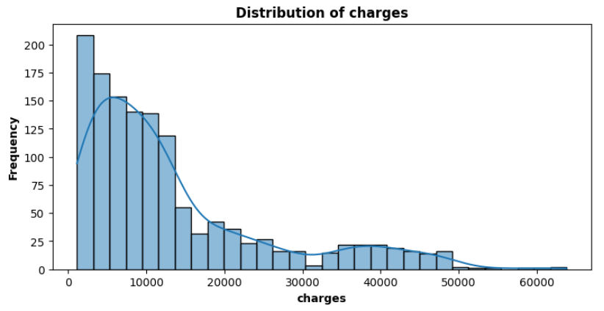

*Fig 4: Distribution of charges*

**Characteristics of Right-Skewness:**

The longer tail on the right side of the distribution suggests the presence of outliers, or individuals with exceptionally high medical charges.

The mean is greater than the median, reinforcing the idea that high-cost outliers are pulling the average charge higher, a common trait of right-skewed distributions.

This skewness suggests that standard linear regression models may need to be adjusted or transformed, such as applying a log transformation, to effectively model the data.

### *Impact of Smoking on Medical Charges*

The data reveals that smokers incur substantially higher medical charges compared to non-smokers.

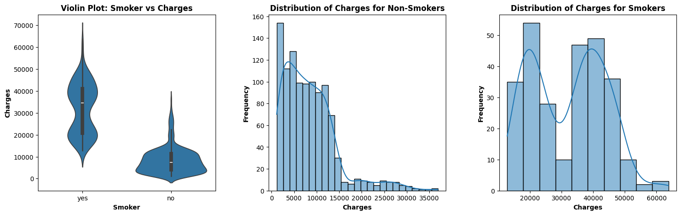

*Fig 5: Impact of smoking on charges*

***Observation:***

The distribution of charges among smokers is significantly broader and shifted towards higher values, indicating that smoking is a strong predictor of elevated healthcare costs.

This difference suggests that smoking status is a critical variable that should be closely examined in predictive modelling, as it directly influences the overall healthcare expenditure.

This finding highlights the importance of including smoking status as a key variable in any predictive model of medical costs.

### *Age and Medical Charges*

The relationship between age and medical charges is positive, though the increase in charges with age is relatively modest.

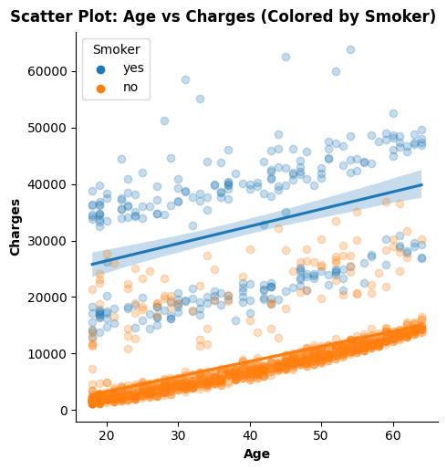

*Fig 6: Age vs charges vs smoke*

***Observation:***

Medical charges tend to rise as individuals age, but the rate of increase is not dramatic.

This pattern could reflect a combination of factors, including the potential for older individuals to have better health management and insurance coverage, which mitigates extreme costs.

This suggests that age is a relevant but not dominant predictor of medical charges and should be included in models in a straightforward manner.

### *Interaction Between BMI, Smoking, and Medical Charges*

A particularly interesting finding is the interaction between Body Mass Index (BMI), smoking status, and medical charges.

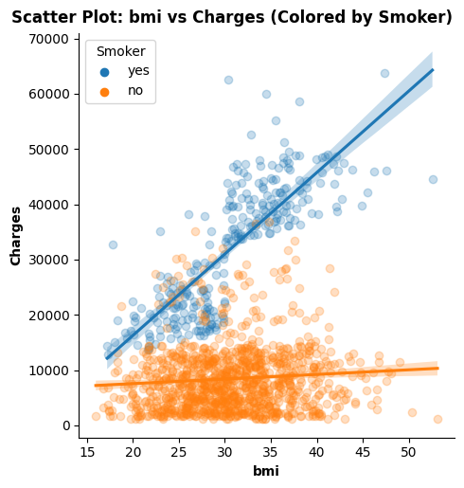

*Fig 7: bmi vs smoke vs charges*

***Observation:***

For non-smokers, increases in BMI lead to only a slight increase in medical charges, suggesting that while higher BMI is associated with higher costs, it does not drastically impact non-smokers.

In contrast, for smokers, the relationship between BMI and charges is exponential. As BMI increases, the medical charges for smokers increase sharply, reflecting the compounded health risks of smoking combined with being overweight.

This indicates that modelling efforts should consider interaction terms or more sophisticated non-linear models to accurately capture the combined effects of BMI and smoking on medical charges.

### *Cluster Analysis in Age vs. Charges*

While analysing the relationship between age and medical charges, three distinct clusters were identified. These clusters prompted further investigation using cluster analysis techniques like K-means and decision trees.

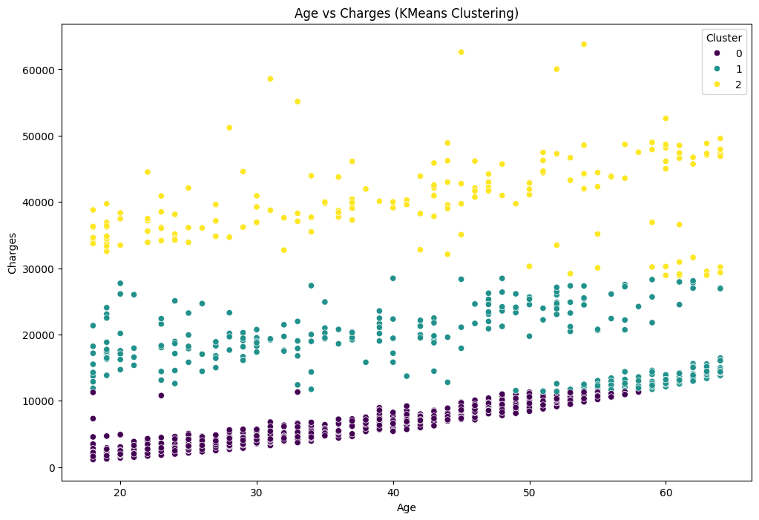 *Fig 8: Cluster Analysis*

*Fig 9: Decision tree for clusters*

0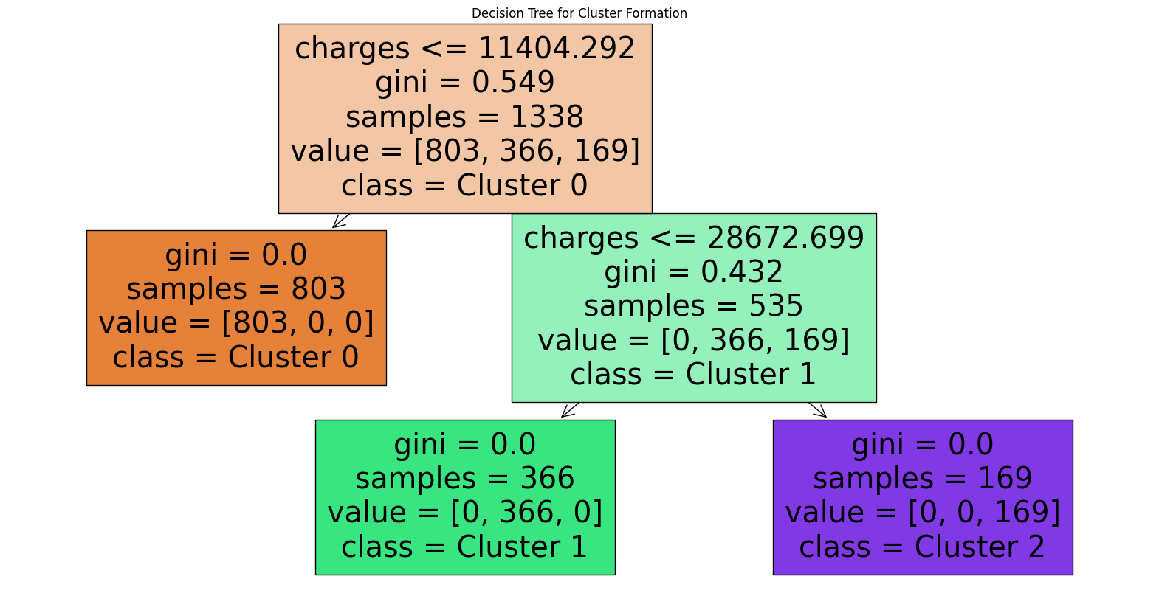

***Observation:***

The clusters suggest that there might be additional, unobserved factors influencing medical charges across different age groups.

Despite attempts to use clustering algorithms to uncover the reasons behind these clusters, no definitive conclusions were drawn, suggesting that there may be missing data or unaccounted variables contributing to these clusters.

This finding highlights a potential limitation in the dataset, where some influential variables might be absent, leading to unexplained clusters in the data. Further investigation or data collection might be necessary to fully understand these.

## Linear Regression

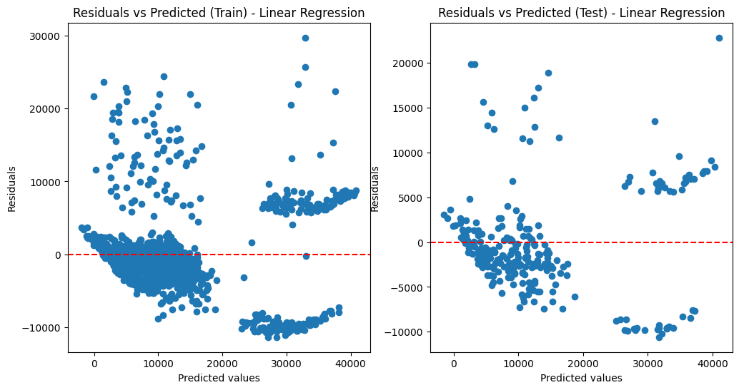

*Fig 8: Linear Regression (Residuals vs predicted values)*

### *Original Data*

*MSE: 33,635,210.43 | R² Score: 0.7833*

Linear Regression on the original dataset provides a decent R² score of 0.7833, which indicates that approximately 78.33% of the variance in the target variable is explained by the model. The Mean Squared Error (MSE) is fairly high, suggesting that while the model captures the overall trend well, there is still significant error in the predictions.

### *Data After Removing High Leverage Points and Outliers*

*MSE: 20,246,819.79 | R² Score: 0.8246*

After removing outliers and high leverage points, the performance of the Linear Regression model improves significantly. The R² score increases to 0.8246, and the MSE drops to 20,246,819.79. This suggests that outliers were skewing the model's predictions, and their removal allowed the model to better fit the majority of the data.

### *After Feature Selection*

*MSE: 34,512,843.88 | R² Score: 0.7777*

When applying feature selection, we see a slight decrease in performance compared to the original model. The R² score drops to 0.7777, and the MSE increases to 34,512,843.88. This indicates that some of the removed features might have been informative, contributing to the model’s ability to explain variance in the target variable.

### *After Feature Selection and Removing Outliers*

*MSE: 17,390,249.24 | R² Score: 0.8706*

Combining feature selection with outlier removal results in the best performance among the Linear Regression models. The R² score improves significantly to 0.8706, and the MSE decreases to 17,390,249.24. This highlights the importance of both selecting the most relevant features and ensuring that the dataset is clean and free from outliers, as both steps lead to a more accurate and reliable model.

## Quantile Regression

Quantile Regression is particularly useful when the distribution of the target variable is not normal or when we are interested in predicting specific percentiles (e.g., median) rather than the mean.

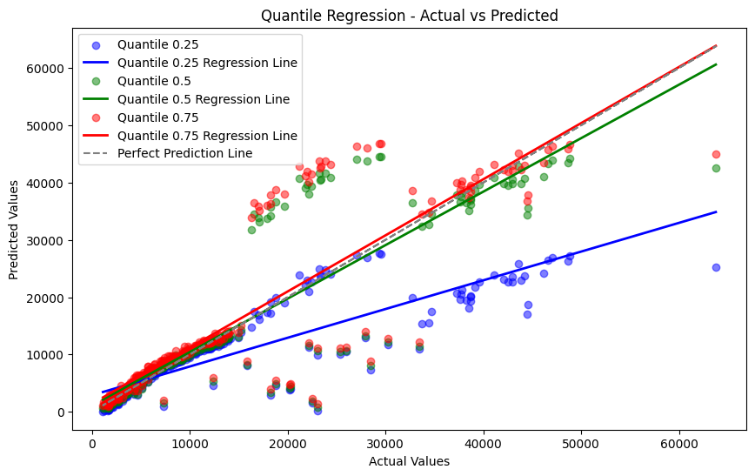

*Fig 9: Quantile Regression*

### *Original Data*

*0.25 Quantile: MSE: 65,145,621.41 | R² Score: 0.5804*

*0.5 Quantile: MSE: 43,265,923.45 | R² Score: 0.7213*

*0.75 Quantile: MSE: 48,150,326.81 | R² Score: 0.6899*

Quantile Regression on the original data shows varying performance across different quantiles. The 0.5 quantile, which corresponds to the median, has a moderate R² score of 0.7213, but with a relatively high MSE. The lower (0.25) and upper (0.75) quantiles perform worse, indicating that the model struggles more with predicting extreme values, which could be due to the presence of outliers and high leverage points in the data.

### *Data After Removing High Leverage Points and Outliers*

*0.25 Quantile: MSE: 41,478,349.08 | R² Score: 0.6407*

*0.5 Quantile: MSE: 32,479,368.47 | R² Score: 0.7187*

*0.75 Quantile: MSE: 37,374,397.14 | R² Score: 0.6763*

Removing outliers improves the performance of Quantile Regression, especially at the 0.25 quantile, where the MSE drops significantly, and the R² score increases. However, the median and 0.75 quantile regressions still exhibit high MSE values, indicating that while outlier removal helps, it does not fully address the model's limitations in capturing the variance in the target variable at different quantiles.

### *After Feature Selection*

*0.25 Quantile: MSE: 65,279,359.16 | R² Score: 0.5795*

*0.5 Quantile: MSE: 43,900,311.25 | R² Score: 0.7172*

*0.75 Quantile: MSE: 49,053,563.95 | R² Score: 0.684*

After feature selection, the performance of Quantile Regression does not improve much, and in some cases, it worsens slightly. This suggests that the removed features were likely important for capturing the variance in the target variable across different quantiles.

### *After Feature Selection and Removing Outliers*

*0.25 Quantile: MSE: 45,526,883.82 | R² Score: 0.6613*

*0.5 Quantile: MSE: 18,599,118.27 | R² Score: 0.8616*

*0.75 Quantile: MSE: 25,483,532.52 | R² Score: 0.8104*

Combining feature selection with outlier removal yields mixed results. The 0.5 quantile regression shows a significant improvement with an R² score of 0.8616, which is quite close to that of Linear Regression, indicating that the median predictions have become much more accurate. However, the performance for the 0.25 and 0.75 quantiles, while improved, still lags behind, reflecting the inherent challenges in modelling the tails of the distribution.

## XGBoost

XGBoost is a powerful ensemble method that often outperforms traditional regression techniques by capturing complex relationships in the data. Let's examine how it compares.

### *XGBoost with Linear Regression*

### Original Data

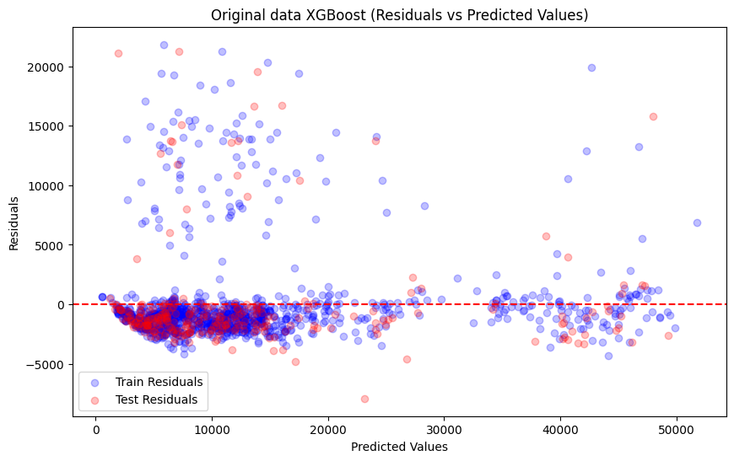

*Fig 10: XGBoost on Linear Regression*

*MSE: 18,008,285.87 | R² Score: 0.884*

XGBoost significantly outperforms standard Linear Regression on the original data, with a much lower MSE and a higher R² score of 0.884. This highlights XGBoost's ability to model non-linear relationships more effectively than linear models.

### Data After Removing High Leverage Points and Outliers

*MSE: 9,062,129.57 | R² Score: 0.9215*

After removing outliers, the performance of XGBoost improves further, achieving an impressive R² score of 0.9215. This shows that even though XGBoost can handle complex data well, it still benefits from data cleaning processes.

### After Feature Selection

*MSE: 18,008,285.87 | R² Score: 0.884*

Interestingly, feature selection does not affect the performance of XGBoost with Linear Regression, which maintains the same MSE and R² score as with the original data. This indicates that XGBoost is robust enough to manage irrelevant or redundant features without a significant drop in performance.

### After Feature Selection and Removing Outliers

*MSE: 4,025,027.47 | R² Score: 0.9701*

The best results are obtained after combining feature selection with outlier removal, where XGBoost achieves an R² score of 0.9701 and a remarkably low MSE. This highlights the potential of XGBoost to produce highly accurate models when the data is well-prepared.

### *XGBoost with Quantile Regression*



### Original Data

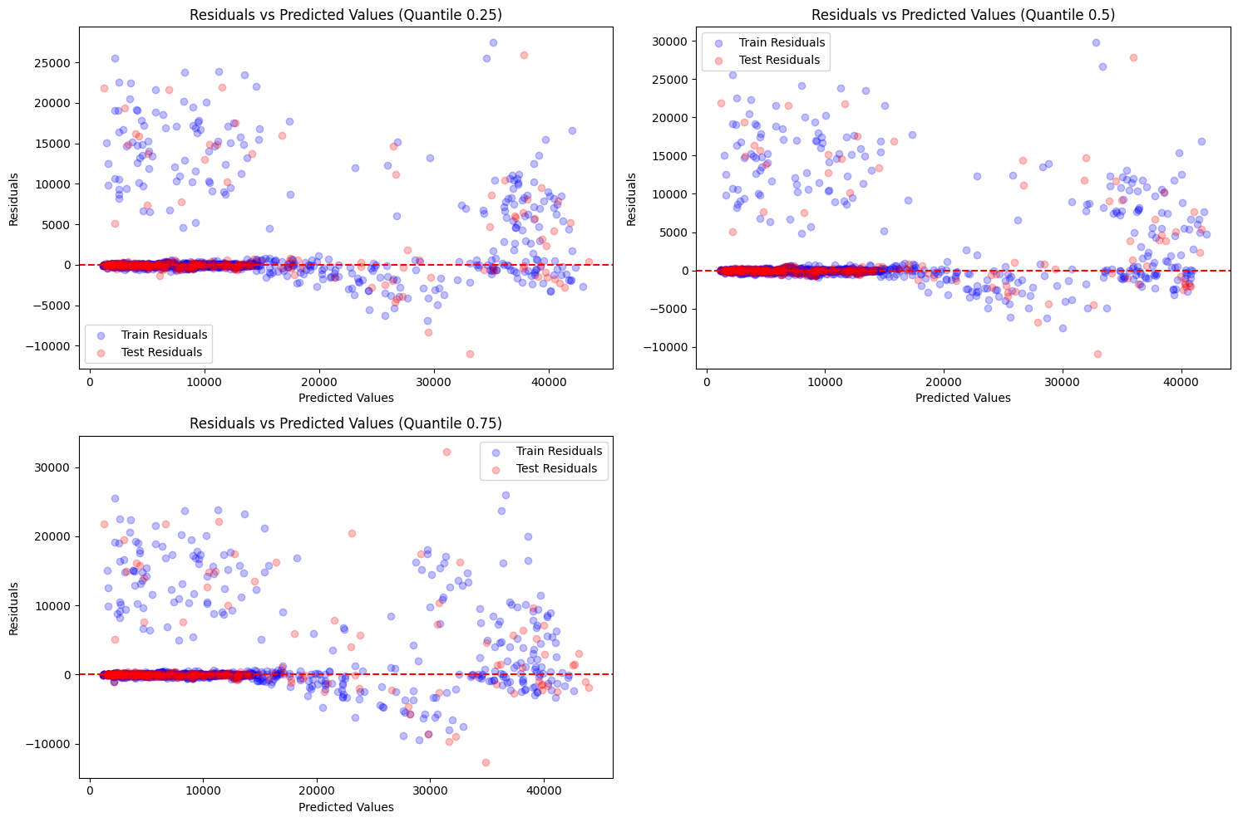

*Fig 11: XGBoost on Quantile Regression (Residual vs Predicted)*

*0.25 Quantile: MSE: 23,468,981.48 | R² Score: 0.8488*

*0.5 Quantile: MSE: 25,111,831.86 | R² Score: 0.8382*

*0.75 Quantile: MSE: 28,049,929.66 | R² Score: 0.8193*

XGBoost with Quantile Regression performs better across all quantiles compared to standard Quantile Regression. The R² scores are substantially higher, indicating that XGBoost effectively captures the distribution of the target variable across different quantiles.

### Data After Removing High Leverage Points and Outliers

*0.25 Quantile: MSE: 19,151,108.50 | R² Score: 0.8341*

*0.5 Quantile: MSE: 20,328,092.58 | R² Score: 0.8239*

*0.75 Quantile: MSE: 19,142,146.50 | R² Score: 0.8342*

Removing outliers further improves the performance of XGBoost with Quantile Regression, particularly at the 0.25 quantile, where the MSE decreases significantly. This suggests that while XGBoost can manage noisy data, cleaner data still results in better predictive performance.

### After Feature Selection

*0.25 Quantile: MSE: 21,090,354.74 | R² Score: 0.8642*

*0.5 Quantile: MSE: 21,122,081.61 | R² Score: 0.8639*

*0.75 Quantile: MSE: 21,659,843.44 | R² Score: 0.8605*

Feature selection does not have a dramatic impact on XGBoost with Quantile Regression, but there is a slight improvement in R² scores, particularly at the 0.25 quantile. This suggests that XGBoost is slightly better at leveraging the most relevant features when predicting different parts of the target distribution.

### After Feature Selection and Removing Outliers

0.25 Quantile: MSE: 6,189,905.89 | R² Score: 0.954

0.5 Quantile: MSE: 5,227,699.18 | R² Score: 0.9611

0.75 Quantile: MSE: 5,210,260.03 | R² Score: 0.9612

After both feature selection and outlier removal, XGBoost with Quantile Regression achieves its best performance, with extremely high R² scores across all quantiles. This confirms the model’s ability to produce highly accurate predictions when the data is both clean and appropriately reduced in dimensionality.

## Comparing Linear Regression and Quantile Regression at 0.5 Quantile

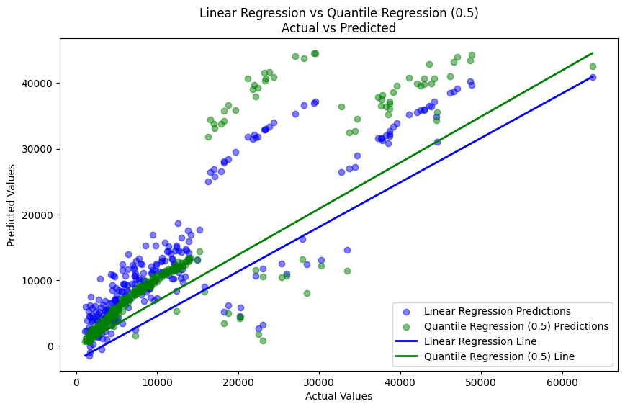

*Fig 12: Linear Regression vs Quantile Regression at 0.5*

### *Original Data*

*Linear Regression MSE: 33,635,210.43 | R² Score: 0.7833*

*Quantile Regression MSE (0.5): 43,265,923.45 | R² Score: 0.7213*

*XGBoost Linear Regression MSE: 18,008,285.87 | R² Score: 0.884*

*XGBoost Quantile Regression MSE (0.5): 25,111,831.86 | R² Score: 0.8382*

XGBoost outperforms both standard Linear Regression and Quantile Regression at the 0.5 quantile on the original data, showing that it is better suited to handling complex relationships. However, it's interesting to note that Linear Regression still does a good job in terms of R² score, but with a higher error (MSE) compared to XGBoost.

### *Data After Removing High Leverage Points and Outliers*

*Linear Regression MSE: 20,246,819.79 | R² Score: 0.8246*

*Quantile Regression MSE (0.5): 32,479,368.47 | R² Score: 0.7187*

*XGBoost Linear Regression MSE: 9,062,129.57 | R² Score: 0.9215*

*XGBoost Quantile Regression MSE (0.5): 20,328,092.58 | R² Score: 0.8239*

Removing outliers boosts the performance of both Linear and Quantile Regression models. However, the XGBoost models show a much more pronounced improvement, particularly in terms of R² scores, indicating that the data cleaning process is highly beneficial for more sophisticated models like XGBoost.

### *After Feature Selection*

*Linear Regression MSE: 34,512,843.88 | R² Score: 0.7777*

*Quantile Regression MSE (0.5): 43,900,311.25 | R² Score: 0.7172*

*XGBoost Linear Regression MSE: 18,008,285.87 | R² Score: 0.884*

*XGBoost Quantile Regression MSE (0.5): 21,122,081.61 | R² Score: 0.8639*

Feature selection alone does not drastically improve model performance, particularly for Linear and Quantile Regression, suggesting that the removed features were somewhat important. XGBoost models, on the other hand, remain robust, showing that they are less sensitive to feature reduction.

### *After Feature Selection and Removing Outliers*

*Linear Regression MSE: 17,390,249.24 | R² Score: 0.8706*

*Quantile Regression MSE (0.5): 18,599,118.27 | R² Score: 0.8616*

*XGBoost Linear Regression MSE: 4,025,027.47 | R² Score: 0.9701*

*XGBoost Quantile Regression MSE (0.5): 5,227,699.18 | R² Score: 0.9611*

Combining feature selection with outlier removal results in the best performance across all models. XGBoost once again shows its superiority, with extremely low MSE and high R² scores, indicating near-perfect prediction capabilities when the data is properly processed. Even standard Linear and Quantile Regression models see a substantial boost in performance, showing that data preprocessing is critical for improving model accuracy.

## Conclusion

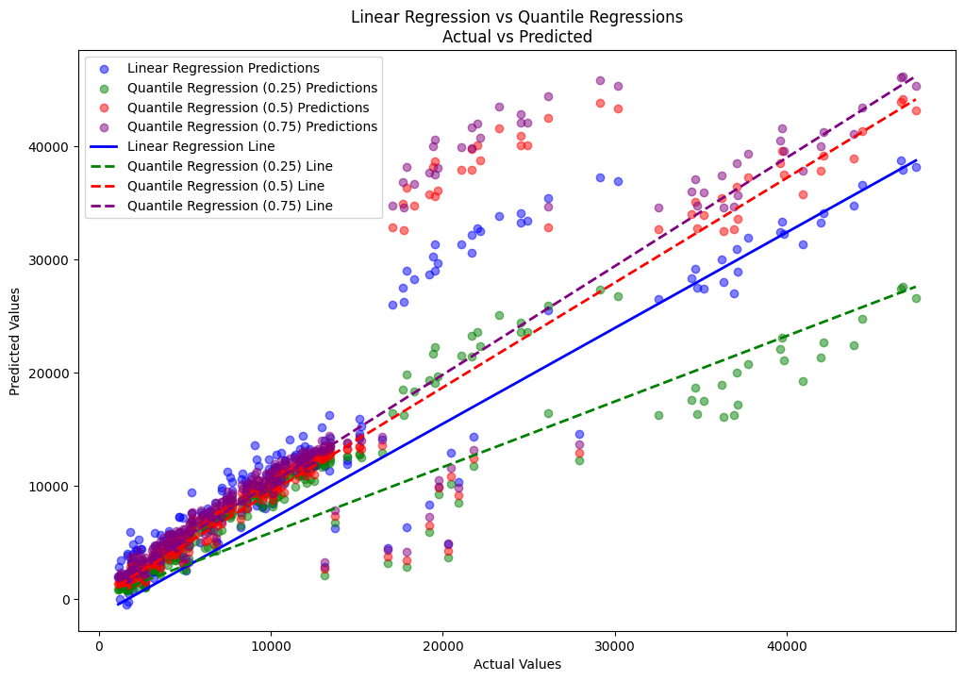

*Fig 13: Linear Regression and Quantile Regression*

Overall, XGBoost consistently outperforms traditional regression methods across all scenarios. While Linear Regression and Quantile Regression perform reasonably well, they benefit significantly from data cleaning and feature selection. XGBoost, however, not only handles the original data well but also improves dramatically with cleaner and more relevant data, making it the best choice for achieving high accuracy in complex datasets.

# Discussion



## Limitations

During the course of our analysis, a significant limitation emerged when we were unable to fully interpret the clusters identified through our clustering techniques. The inability to understand these clusters suggests that critical variables may be missing from our dataset. This lack of information likely prevented us from uncovering deeper patterns or behaviours in the medical cost data. It’s possible that the inclusion of additional features, such as socioeconomic status, lifestyle factors, or even geographical data, could have provided the missing context needed to explain these clusters.

## Improvements and Future Scope

### *Interpretation of Results*

The results of our analysis reveal several important insights:

***Linear Regression:*** Linear regression, although simple and widely used, did not perform as well as other methods. Its limitations became apparent in handling non-linear relationships and interactions within the data, which are crucial in predicting medical costs.

**Quantile Regression:** Quantile regression offered a nuanced approach by predicting different quantiles of the dependent variable, allowing for a more detailed understanding of the data's distribution. However, it did not consistently outperform traditional methods in terms of accuracy, possibly due to the complexity of the dataset and the high variability in medical costs.

***XGBoost:*** XGBoost consistently outperformed other models, demonstrating superior performance in all scenarios. This is likely due to its ability to manage complex interactions, capture non-linear relationships, and robustly handle outliers and multicollinearity. XGBoost's tree-based approach allows it to model complex patterns that simpler methods may miss.

### *Comparison to Literature*

Our results showed that while quantile regression offered some advantages, particularly in capturing the variability at different points in the cost distribution, it did not consistently outperform linear regression models in terms of prediction accuracy. This finding contrasts with some existing studies that have highlighted the strengths of quantile regression in dealing with heteroscedasticity and non-normality in data. The difference in results may be attributed to the specific characteristics of our dataset, such as its skewed distribution and the presence of outliers, which may have favoured the performance of more sophisticated models like XGBoost.

### Limitations of Results

Several limitations impact the interpretation and generalizability of our results:

***Missing Data and Variables:*** The potential absence of key variables might have limited the depth of our analysis. This is particularly evident in our clustering analysis, where the lack of additional contextual data made it difficult to explain the identified clusters.

***Model Generalizability:*** The performance of models like XGBoost, while strong in this specific dataset, may not generalize as well to different datasets, particularly those with different distributions or less complex relationships.

### Relation to Project Objectives

Uncovering Hidden Patterns: While we successfully uncovered some patterns in the data, the unexplained clusters suggest that our analysis may not have fully captured all the underlying behaviours in the medical cost dataset. This relates directly to the first research question, highlighting the need for more comprehensive data to better understand the patterns.

***Effect of Variable Selection and Multicollinearity***: Our analysis confirmed that variable selection and addressing multicollinearity significantly impact model performance. XGBoost's ability to handle these aspects contributed to its superior performance, aligning with our second research question.

***Comparing Regression Models:*** The comparison between quantile regression and traditional regression techniques revealed that while quantile regression provides a more detailed understanding of different segments of the data, traditional methods, particularly when enhanced by techniques like XGBoost, often yield better predictive performance. This directly addresses the third research question.

### Practical Use of Models

Among the models tested, XGBoost emerges as the most practical for real-world applications, particularly in predicting medical costs. Its robustness in handling outliers, multicollinearity, and complex interactions makes it suitable for deployment in environments where accuracy and reliability are critical. The model’s ability to generalize well across different datasets also suggests its utility in various predictive analytics scenarios within the healthcare industry.

### Answering the Research Questions

Overall, the study has made significant progress in answering the research questions posed:

***Hidden Patterns:*** While we uncovered some hidden patterns, the unexplained clusters suggest that there is more to be discovered, likely requiring additional data.

***Variable Effects:*** The study clearly demonstrated how variable selection, interaction effects, and multicollinearity influence regression models, particularly highlighting the strengths of models like XGBoost.

***Model Comparison:*** The comparison between quantile regression and traditional regression techniques showed that while quantile regression is useful, traditional models, especially when boosted, often perform better in terms of predictive accuracy.

In conclusion, while the study has provided valuable insights into the behaviour of medical cost data and the performance of various predictive models, it also highlights the need for more comprehensive datasets and further exploration to fully understand and leverage these models in practical applications.

# Conclusion

In this study, we set out to analyse and predict medical costs using various regression techniques, with a focus on understanding the hidden patterns within the data, the effects of variable selection and multicollinearity, and comparing the performance of traditional and quantile regression models.

Initially, our exploratory data analysis revealed significant variability in the medical costs, highlighting the complexity of the data. We encountered challenges, particularly with unexplained clusters, which suggested the absence of key variables that could have provided further insight into the dataset's underlying patterns.

Linear regression, while straightforward, showed limitations in its ability to handle non-linear relationships and the inherent complexities within the data. Quantile regression offered a more detailed perspective by estimating different points in the cost distribution, but it did not consistently surpass traditional methods in predictive accuracy. The standout performer was XGBoost, a powerful machine learning algorithm that excelled across all data scenarios. XGBoost's strength lies in its ability to manage multicollinearity, handle outliers effectively, and capture complex interactions, making it the most practical model for real-world applications in this context.

Our analysis affirmed the critical role of variable selection and the management of multicollinearity in enhancing model performance. Moreover, the comparison between quantile regression and traditional regression techniques underscored the practical advantages of using more advanced, tree-based models like XGBoost in predicting medical costs.

In conclusion, this study not only answered the research questions but also demonstrated the importance of robust data and advanced modelling techniques in predictive analytics. While we made significant progress in understanding the dataset and predicting medical costs, the study also highlighted areas for further exploration, particularly in obtaining more comprehensive data to fully uncover the hidden patterns within the medical cost landscape.

# References

Buntin, M.B. & Zaslavsky, A.M., 2004. Too much ado about two-part models and transformation? Comparing methods of modeling Medicare expenditures. *Journal of Health Economics*, 23(3), pp.525-542. doi: 10.1016/j.jhealeco.2003.10.005. Available at: <https://doi.org/10.1016/j.jhealeco.2003.10.005> [Accessed 25 Aug. 2024].

DeMaris, A., 2004. *Regression with social data: Modeling continuous and limited response variables*. Wiley-Interscience. Available at: <https://onlinelibrary.wiley.com/doi/book/10.1002/0471677566> [Accessed 25 Aug. 2024].

Dodd, S., Bassi, A., Bodger, K. & Williamson, P., 2006. A comparison of multivariable regression models to analyse cost data. *Journal of Evaluation in Clinical Practice*, 12(1), pp.76-86. doi: 10.1111/j.1365-2753.2006.00610.x. Available at: <https://pubmed.ncbi.nlm.nih.gov/16422782/> [Accessed 25 Aug. 2024].

Kaushik, K., Bhardwaj, A., Dwivedi, A.D., and Singh, R., 2022. Machine learning-based regression framework to predict health insurance premiums. *International Journal of Environmental Research and Public Health*, 19(13), p.7898. Available at: <https://doi.org/10.3390/ijerph19137898> [Accessed 25 Aug. 2024].

Koenker, R. & Bassett, G., 1978. Regression quantiles. *Econometrica*, 46(1), pp.33-50. Available at: <https://doi.org/10.2307/1913643> [Accessed 25 Aug. 2024].

Newhouse, J.P., 1992. Medical care costs: how much welfare loss? *Journal of Economic Perspectives*, 6(3), pp.3-21. doi: 10.1257/jep.6.3.3. Available at: <https://www.aeaweb.org/articles?id=10.1257/jep.6.3.3> [Accessed 25 Aug. 2024].

Panda, S., Purkayastha, B., Das, D., Chakraborty, M., and Biswas, S.K., 2022. Health insurance cost prediction using regression models. In: 2022 International Conference on Machine Learning, Big Data, Cloud and Parallel Computing (COM-IT-CON). IEEE, pp. 168-173. Available at: <https://doi.org/10.1109/COM-IT-CON54601.2022.9850653> [Accessed 25 Aug. 2024].

Staffa, S.J., Kohane, D.S. and Zurakowski, D., 2019. Quantile regression and its applications: A primer for anesthesiologists. *Anesthesia & Analgesia*, 128(4), pp.820-830. DOI: 10.1213/ANE.0000000000004017. Available at: <https://journals.lww.com/anesthesia-analgesia/fulltext/2019/04000/quantile_regression_and_its_applications__a_primer.28.aspx#JCL-P-8> [Accessed 25 Aug. 2024].

Tufail, S., Riggs, H., Tariq, M., and Sarwat, A.I., 2023. Advancements and challenges in machine learning: A comprehensive review of models, libraries, applications, and algorithms. *Electronics*, 12(8), p.1789. Available at: <https://doi.org/10.3390/electronics12081789> [Accessed 27 August 2024].

Yu, K. & Moyeed, R.A., 2001. Bayesian quantile regression. *Statistics & Probability Letters*, 54(4), pp.437-447. doi: 10.1016/S0167-7152(01)00124-9. Available at: <https://doi.org/10.1016/S0167-7152(01)00124-9> [Accessed 25 Aug. 2024].

Zou, S., Chu, C., Shen, N., and Ren, J., 2023. Healthcare cost prediction based on hybrid machine learning algorithms. *Mathematics*, 11(23), p.4778. Available at: <https://doi.org/10.3390/math11234778> [Accessed 27 August 2024].

# Appendices

# -*- coding: utf-8 -*-

"""Medical insurance cost prediction.ipynb

Automatically generated by Colab.

Original file is located at

Kaggle: https://www.kaggle.com/datasets/mirichoi0218/insurance https://colab.research.google.com/drive/1Ox1DCyPXoJuoVIh3Zj9VyMuuwUb2C907

Github: <https://github.com/shubhamvm/MScDataScience/tree/main/Data%20Science%20Project>

#Medical Insurance Cost Prediction

##Traditional Regression Vs Quantile Regression

Here, We will explore a dataset consists of patients data for medical cost. The cost of medical treatment depends on many factors: number of diseases, diseases, bmi, , diagbosis, number of childeren, city of residence, age and so on. We have data which can help us to find patterns or draw conclusion about health of patients and their medical costs. But we dont have personal data like diseases and diagnosis.

Let's jump into data and explore it.

### Importing necessary libraries

"""

#!pip install deap

import pandas as pd

import matplotlib.pyplot as plt

import seaborn as sns

import numpy as np

import xgboost as xgb

from sklearn.model_selection import train_test_split

from sklearn.preprocessing import StandardScaler, OneHotEncoder

from sklearn.compose import ColumnTransformer

from sklearn.pipeline import Pipeline

import statsmodels.api as sm

from statsmodels.formula.api import ols

from statsmodels.stats.anova import anova_lm

import statsmodels.api as sm

from statsmodels.stats.outliers_influence import variance_inflation_factor

from sklearn.preprocessing import OneHotEncoder

from sklearn.feature_selection import RFECV

from sklearn.linear_model import LinearRegression

#from deap import base, creator, tools, algorithms

import numpy as np

from sklearn.model_selection import train_test_split

from sklearn.metrics import mean_squared_error

from sklearn.feature_selection import SelectKBest, chi2

from sklearn.preprocessing import StandardScaler, OneHotEncoder

from sklearn.compose import ColumnTransformer

from scipy.stats import norm

import matplotlib as mpl

from sklearn.model_selection import train_test_split

from sklearn.metrics import mean_squared_error, r2_score

from sklearn.preprocessing import PolynomialFeatures

from sklearn.linear_model import Ridge, Lasso, LinearRegression

"""Importing Data"""

# Load the dataset

file_path = 'https://raw.githubusercontent.com/shubhamvm/Kaggle/main/Final%20Project/Datasets/insurance.csv'

data = pd.read_csv(file_path)

data.head()

# Check for missing values

missing_values = data.isnull().sum()

print("Missing Values in Each Column:")

print(missing_values)

# Check data types

data_types = data.dtypes

print("\nData Types of Each Column:")

print(data_types)

# Summary statistics for all columns

summary_stats = data.describe(include='all')

print("\nSummary Statistics:")

print(summary_stats)

# Define the numerical features

numerical_cols = ['charges', 'age', 'bmi', 'children']

# Set up the figure and axes

fig, axes = plt.subplots(nrows=2, ncols=2, figsize=(20, 10))

axes = axes.flatten()

# Plot the distributions

for i, col in enumerate(numerical_cols):

sns.histplot(data=data, x=col, bins=30, kde=True, ax=axes[i])

axes[i].set_title(f'Distribution of {col}', fontweight='bold')

axes[i].set_xlabel(col, fontweight='semibold')

axes[i].set_ylabel('Frequency', fontweight='semibold')

# Adjust spacing between subplots

plt.subplots_adjust(hspace=0.5, wspace=0.3)

# Display the plot

plt.show()

# Define the numerical and categorical features

numerical_cols = ['age', 'bmi', 'children']

categorical_cols = ['sex', 'smoker', 'region']

# Set up the figure and axes

fig, axes = plt.subplots(nrows=2, ncols=3, figsize=(18, 10))

axes = axes.flatten()

# Scatter plots for numerical variables vs. charges

for i, col in enumerate(numerical_cols):

if col != 'charges':

sns.scatterplot(x=data[col], y=data['charges'], ax=axes[i])

axes[i].set_title(f'{col} vs Charges', fontweight='bold')

axes[i].set_xlabel(col, fontweight='semibold')

axes[i].set_ylabel('Charges', fontweight='semibold')

# Box plots for categorical variables vs. charges

for i, col in enumerate(categorical_cols, start=len(numerical_cols)):

sns.boxplot(x=data[col], y=data['charges'], ax=axes[i])

axes[i].set_title(f'{col} vs Charges', fontweight='bold')

axes[i].set_xlabel(col, fontweight='semibold')

axes[i].set_ylabel('Charges', fontweight='semibold')

# Adjust spacing between subplots

plt.subplots_adjust(hspace=0.5, wspace=0.3)

# Display the plot

plt.show()

# Convert categorical variables to numerical codes

data_numeric = data.copy()

data_numeric['sex'] = data_numeric['sex'].astype('category').cat.codes

data_numeric['smoker'] = data_numeric['smoker'].astype('category').cat.codes

data_numeric['region'] = data_numeric['region'].astype('category').cat.codes

# Display the first few rows of the resulting dataframe

data_numeric.head()

"""region: northwest = 1, southeast = 2, southwest = 3, northeast = 4

sex: female = 0, male = 1

smoker: smoker = 1, non-smoker = 0

"""

# Compute the correlation matrix

correlation_matrix = data_numeric.corr()

# Display the correlation matrix

print(correlation_matrix)

# Plot the correlation matrix

import seaborn as sns

import matplotlib.pyplot as plt

plt.figure(figsize=(12, 8))

sns.heatmap(correlation_matrix, annot=True, cmap='coolwarm', linewidths=0.5)

plt.title('Correlation Matrix', fontweight='bold')

plt.show()

# Define the numerical and categorical features

numerical_cols = ['age', 'bmi', 'children']

categorical_cols = ['sex', 'smoker', 'region']

# Take log of 'charges' column

data['log_charges'] = np.log(data['charges'])

# Set up the figure and axes

fig, axes = plt.subplots(nrows=2, ncols=3, figsize=(18, 10))

axes = axes.flatten()

# Scatter plots for numerical variables vs. charges

for i, col in enumerate(numerical_cols):

if col != 'charges':

sns.scatterplot(x=data[col], y=data['log_charges'], ax=axes[i])

axes[i].set_title(f'{col} vs Log(Charges)', fontweight='bold')

axes[i].set_xlabel(col, fontweight='semibold')

axes[i].set_ylabel('Log(Charges)', fontweight='semibold')

# Box plots for categorical variables vs. charges

for i, col in enumerate(categorical_cols, start=len(numerical_cols)):

sns.boxplot(x=data[col], y=data['log_charges'], ax=axes[i])

axes[i].set_title(f'{col} vs Log(Charges)', fontweight='bold')

axes[i].set_xlabel(col, fontweight='semibold')

axes[i].set_ylabel('Log(Charges)', fontweight='semibold')

# Adjust spacing between subplots

plt.subplots_adjust(hspace=0.5, wspace=0.3)

# Display the plot

plt.show()

# Define the numerical feature

numerical_col = 'charges'

# Plot the histogram and kernel density estimate

plt.figure(figsize=(10, 6))

sns.histplot(data=data, x=numerical_col, kde=True, stat="density", bins=30, color="skyblue")

# Create a range of values for the x-axis

xmin, xmax = plt.xlim()

ymin, ymax = plt.ylim()

x = np.linspace(xmin, xmax, 100)

# Fit the data to a normal distribution

mean_value, std_dev = norm.fit(data[numerical_col])

# Plot the PDF using the normal distribution

pdf = norm.pdf(x, mean_value, std_dev)

plt.plot(x, pdf, 'k', linewidth=2)

# Plot mean and standard deviation lines

plt.axvline(mean_value, color='red', linestyle='dashed', linewidth=2, label=f'Mean = {mean_value:.2f}')

plt.axvline(mean_value - std_dev, color='green', linestyle='dashed', linewidth=2, label=f'Mean - Std Dev = {(mean_value - std_dev):.2f}')

plt.axvline(mean_value + std_dev, color='green', linestyle='dashed', linewidth=2, label=f'Mean + Std Dev = {(mean_value + std_dev):.2f}')

# Fill the area between mean - std_dev and mean + std_dev with color

x_fill = np.linspace(mean_value - std_dev, mean_value + std_dev, 100)

y_fill = np.exp(-(x_fill - mean_value)**2 / (2 * std_dev**2)) / (std_dev * np.sqrt(2 * np.pi))

plt.fill_between(x_fill, y_fill, color='red', alpha=0.3, label='Mean ± Std Dev Area')

# Add text annotations

plt.text(xmax * 0.6, ymax * 0.5, f'Mean Charges (W~): {mean_value:.2f}', fontsize=10, color='red')

plt.text(xmax * 0.6, ymax * 0.45, f'Standard Deviation (X): {std_dev:.2f}', fontsize=10, color='green')

# Set plot labels and title

plt.xlabel('Charges ($)', fontweight='bold')

plt.ylabel('Probability Density', fontweight='bold')

plt.title('Probability Density Function with Mean and Standard Deviation', fontweight='bold')

# Add legend

plt.legend()

# Display the plot

plt.show()

# Define the numerical feature

numerical_col = 'log_charges'

# Plot the histogram and kernel density estimate

plt.figure(figsize=(10, 6))

sns.histplot(data=data, x=numerical_col, kde=True, stat="density", bins=30, color="skyblue")

# Create a range of values for the x-axis

xmin, xmax = plt.xlim()

ymin, ymax = plt.ylim()

x = np.linspace(xmin, xmax, 100)

# Fit the data to a normal distribution

mean_value, std_dev = norm.fit(data[numerical_col])

# Plot the PDF using the normal distribution

pdf = norm.pdf(x, mean_value, std_dev)

plt.plot(x, pdf, 'k', linewidth=2)

# Plot mean and standard deviation lines

plt.axvline(mean_value, color='red', linestyle='dashed', linewidth=2, label=f'Mean = {mean_value:.2f}')

plt.axvline(mean_value - std_dev, color='green', linestyle='dashed', linewidth=2, label=f'Mean - Std Dev = {(mean_value - std_dev):.2f}')

plt.axvline(mean_value + std_dev, color='green', linestyle='dashed', linewidth=2, label=f'Mean + Std Dev = {(mean_value + std_dev):.2f}')

# Fill the area between mean - std_dev and mean + std_dev with color

x_fill = np.linspace(mean_value - std_dev, mean_value + std_dev, 100)

y_fill = np.exp(-(x_fill - mean_value)**2 / (2 * std_dev**2)) / (std_dev * np.sqrt(2 * np.pi))

plt.fill_between(x_fill, y_fill, color='red', alpha=0.3, label='Mean ± Std Dev Area')

# Add text annotations

plt.text(xmax * 0.6, ymax * 0.5, f'Mean Charges (W~): {mean_value:.2f}', fontsize=10, color='red')

plt.text(xmax * 0.6, ymax * 0.45, f'Standard Deviation (X): {std_dev:.2f}', fontsize=10, color='green')

# Set plot labels and title

plt.xlabel('log_charges ($)', fontweight='bold')

plt.ylabel('Probability Density', fontweight='bold')

plt.title('Probability Density Function with Mean and Standard Deviation', fontweight='bold')

# Add legend

plt.legend()

# Display the plot

plt.show()

# Set up the figure and axes

fig, axes = plt.subplots(nrows=1, ncols=3, figsize=(18, 5))

# Violin plot for all smokers vs charges

sns.violinplot(x='smoker', y='charges', data=data, ax=axes[0])

axes[0].set_title('Violin Plot: Smoker vs Charges', fontweight='bold')

axes[0].set_xlabel('Smoker', fontweight='semibold')

axes[0].set_ylabel('Charges', fontweight='semibold')

# Distribution plot of charges for non-smokers

non_smokers = data[data['smoker'] == 'no']

sns.histplot(non_smokers['charges'], kde=True, ax=axes[1])

axes[1].set_title('Distribution of Charges for Non-Smokers', fontweight='bold')

axes[1].set_xlabel('Charges', fontweight='semibold')

axes[1].set_ylabel('Frequency', fontweight='semibold')

# Distribution plot of charges for smokers

smokers = data[data['smoker'] == 'yes']

sns.histplot(smokers['charges'], kde=True, ax=axes[2])

axes[2].set_title('Distribution of Charges for Smokers', fontweight='bold')

axes[2].set_xlabel('Charges', fontweight='semibold')

axes[2].set_ylabel('Frequency', fontweight='semibold')

# Adjust spacing between subplots

plt.subplots_adjust(wspace=0.3)

# Display the plot

plt.show()

"""Smoking patients spend more on health rather than non smokers. Let's see if charges depends on more variables or not."""

# Set up the figure and axis

plt.figure(figsize=(10, 6))

# Scatter plot with regression lines for smokers and non-smokers

g = sns.lmplot(x='age', y='charges', hue='smoker', data=data, legend=False)

# Set plot labels and title

g.fig.suptitle('Scatter Plot: Age vs Charges (Colored by Smoker)', fontweight='bold', y=1.02)

g.set_axis_labels('Age', 'Charges', fontweight='semibold')

# Make the visibility of each dot 50%

for artist in g.ax.collections:

artist.set_alpha(0.25)

# Add legend on the left

leg = g.ax.legend(title='Smoker', title_fontsize='medium', loc='upper left')

for lh in leg.legend_handles:

lh.set_alpha(1) # Make legend markers opaque

# Display the plot

plt.show()

# Define the age bins

age_bins = [18, 25, 35, 45, 55, 65]

data['age_group'] = pd.cut(data['age'], bins=age_bins)

# Group by age group and smoker status and calculate average charges

grouped_data = data.groupby(['age_group', 'smoker'])['charges'].mean().reset_index()

# Plot the results

plt.figure(figsize=(12, 8))

sns.barplot(x='age_group', y='charges', hue='smoker', data=grouped_data)

plt.title('Average Charges by Age Group and Smoking Status', fontweight='bold')

plt.xlabel('Age Group', fontweight='semibold')

plt.ylabel('Average Charges', fontweight='semibold')

plt.legend(title='Smoker')

plt.xticks(rotation=45)

plt.show()

# Define the age bins

age_bins = [18, 25, 35, 45, 55, 65]

age_labels = ['18-24', '25-34', '35-44', '45-54', '55-64']

data['age_group'] = pd.cut(data['age'], bins=age_bins, labels=age_labels, right=False)

# Create a distribution plot for the age groups

plt.figure(figsize=(10, 6))

sns.histplot(data=data, x='age_group', discrete=True)

plt.title('Distribution of Age Groups', fontweight='bold')

plt.xlabel('Age Group', fontweight='semibold')

plt.ylabel('Density', fontweight='semibold')

plt.show()

# Set up the figure and axis

plt.figure(figsize=(10, 6))

# Scatter plot with regression lines for smokers and non-smokers

g = sns.lmplot(x='bmi', y='charges', hue='smoker', data=data, legend=False)

# Set plot labels and title

g.fig.suptitle('Scatter Plot: bmi vs Charges (Colored by Smoker)', fontweight='bold', y=1.02)

g.set_axis_labels('bmi', 'Charges', fontweight='semibold')

# Make the visibility of each dot 50%

for artist in g.ax.collections:

artist.set_alpha(0.25)

# Add legend on the left

leg = g.ax.legend(title='Smoker', title_fontsize='medium', loc='upper left')

for lh in leg.legend_handles:

lh.set_alpha(1) # Make legend markers opaque

# Display the plot

plt.show()

# Set up the figure and axis

plt.figure(figsize=(10, 6))

# Scatter plot with regression lines for smokers and non-smokers

g = sns.lmplot(x='bmi', y='log_charges', hue='smoker', data=data, legend=False)

# Set plot labels and title

g.fig.suptitle('Scatter Plot: bmi vs Log(Charges) (Colored by Smoker)', fontweight='bold', y=1.02)

g.set_axis_labels('bmi', 'Log(Charges)', fontweight='semibold')

# Make the visibility of each dot 50%

for artist in g.ax.collections:

artist.set_alpha(0.25)

# Add legend on the left

leg = g.ax.legend(title='Smoker', title_fontsize='medium', loc='upper left')

for lh in leg.legend_handles:

lh.set_alpha(1) # Make legend markers opaque

# Display the plot

plt.show()

# Set up the figure and axis

plt.figure(figsize=(10, 6))

# Scatter plot with regression lines for smokers and non-smokers

g = sns.lmplot(x='age', y='bmi', hue='smoker', data=data, legend=False)

# Set plot labels and title

g.fig.suptitle('Scatter Plot: Age vs bmi (Colored by Smoker)', fontweight='bold', y=1.02)

g.set_axis_labels('age', 'bmi', fontweight='semibold')

# Make the visibility of each dot 50%

for artist in g.ax.collections:

artist.set_alpha(0.25)

# Add legend on the left

leg = g.ax.legend(title='Smoker', title_fontsize='medium', loc='upper left')

for lh in leg.legend_handles:

lh.set_alpha(1) # Make legend markers opaque

# Display the plot

plt.show()

"""Interesting findings, if bmi increases of non-smoker, charges doesn't go much higher but for smokers, it exponentially increases."""

# Convert categorical variables to numerical codes

data_num = data.copy()

data_num['sex'] = data_num['sex'].astype('category').cat.codes

data_num['smoker'] = data_num['smoker'].astype('category').cat.codes

data_num = data_num.drop(['log_charges', 'age_group'], axis=1)

# One-hot encode the 'region' column with 0/1 values

data_encoded = pd.get_dummies(data_num, columns=['region'], dtype='uint8')

# Display the first few rows of the resulting dataframe

data_encoded.head()

"""Feature Selection

VIF

"""

X = data_encoded.drop('charges', axis=1)

# Add a constant term to the independent variable matrix

X = sm.add_constant(X)

vif = pd.DataFrame()

vif['VIF'] = [variance_inflation_factor(X.values, i) for i in range(X.shape[1])]

vif['feature'] = X.columns

# Sort the VIF values in ascending order

vif = vif.sort_values('VIF', ascending=True)

print(vif)

"""ANOVA (Analysis of Variance)"""

# Assuming 'data_encoded' is your DataFrame with independent variables

X = data_encoded.drop('charges', axis=1)

y = data_encoded['charges']

anova_results = {}

for feature in X.columns:

groups = X[feature].unique()

data_groups = [y[X[feature] == group] for group in groups]

f_value, p_value = f_oneway(*data_groups)

anova_results[feature] = p_value

anova_results = pd.DataFrame.from_dict(anova_results, orient='index', columns=['p_value'])

anova_results = anova_results.sort_values(by='p_value', ascending=True)

print(anova_results)

"""RFECV (Recursive Feature Elimination with Cross-Validation):

RFECV is a method that recursively removes features and evaluates the model performance using cross-validation.

"""

X = data_numeric.drop('charges', axis=1)

y = data_numeric['charges']

model = LinearRegression()

rfecv = RFECV(estimator=model, step=1, cv=5, scoring='neg_mean_squared_error')

rfecv.fit(X, y)

print("Optimal number of features: {}".format(rfecv.n_features_))

print("Selected features: {}".format(X.columns[rfecv.support_]))

# Plot number of features vs. cross-validation scores

plt.figure()

plt.xlabel("Number of features selected")

plt.ylabel("Cross-validation score (MSE)")

plt.plot(range(1, len(rfecv.cv_results_['mean_test_score']) + 1), rfecv.cv_results_['mean_test_score'])

plt.show()

"""**Random Forest Importance:**

Random Forest models can provide feature importance scores, which can be used for feature selection.

"""

from sklearn.ensemble import RandomForestRegressor

rf = RandomForestRegressor(n_estimators=100, random_state=42)

rf.fit(X, y)

importances = pd.DataFrame({'feature': X.columns, 'importance': rf.feature_importances_})

importances = importances.sort_values(by='importance', ascending=False)

print(importances)

"""Pearson Correlation Coefficient:

The Pearson Correlation Coefficient measures the linear relationship between two variables. You can calculate the correlation between each independent variable and the target variable to identify the most relevant features.

"""

corr_coefficients = X.corrwith(y)

corr_coefficients = corr_coefficients.sort_values(ascending=False)

print(corr_coefficients)

from sklearn.cluster import KMeans

# Select the features for clustering

features = data[['age', 'charges']]

# Perform K-means clustering

kmeans = KMeans(n_clusters=3, random_state=42)

cluster_labels = kmeans.fit_predict(features)

# Add cluster labels to the original dataframe

data['cluster'] = cluster_labels

# Create separate dataframes for each cluster

cluster_0 = data[data['cluster'] == 0]

cluster_1 = data[data['cluster'] == 1]

cluster_2 = data[data['cluster'] == 2]

# Print the size of each cluster

print("Cluster 0 size:", len(cluster_0))

print("Cluster 1 size:", len(cluster_1))

print("Cluster 2 size:", len(cluster_2))

# Display the first few rows of each cluster

print("\nCluster 0:")

print(cluster_0.head())

print("\nCluster 1:")

print(cluster_1.head())

print("\nCluster 2:")

print(cluster_2.head())

data.head()

# Select the features for clustering

cl_features = data[['age', 'charges']]

# Perform K-means clustering

kmeans = KMeans(n_clusters=3, random_state=42)

cluster_labels = kmeans.fit_predict(cl_features)

# Create a new DataFrame with the original data and cluster labels

clustered_data = data_numeric.copy()

clustered_data['cluster'] = cluster_labels

# Plot the original scatter plot with clusters

plt.figure(figsize=(12, 8))

sns.scatterplot(x='age', y='charges', hue='cluster', data=clustered_data, palette='viridis')

plt.title('Age vs Charges (KMeans Clustering)')

plt.xlabel('Age')

plt.ylabel('Charges')

plt.legend(title='Cluster')

plt.show()

# Create separate dataframes for each cluster

cluster_0 = data[data['cluster'] == 0]

cluster_1 = data[data['cluster'] == 1]

cluster_2 = data[data['cluster'] == 2]

# Plot separate graphs for each cluster

fig, axs = plt.subplots(1, 3, figsize=(18, 6))

fig.suptitle('Age vs Charges by Cluster (KMeans)', fontsize=16)

sns.scatterplot(x='age', y='charges', data=cluster_0, ax=axs[0], color='purple')

axs[0].set_title('Cluster 0')

sns.scatterplot(x='age', y='charges', data=cluster_1, ax=axs[1], color='green')

axs[1].set_title('Cluster 1')

sns.scatterplot(x='age', y='charges', data=cluster_2, ax=axs[2], color='orange')

axs[2].set_title('Cluster 2')

for ax in axs:

ax.set_xlabel('Age')

ax.set_ylabel('Charges')

plt.tight_layout()

plt.show()

# Print cluster sizes

for i in range(3):

print(f"Cluster {i} size:", len(data[data['cluster'] == i]))

data.head()

# Summary statistics of each cluster

cluster_summary = clustered_data.groupby('cluster').mean()

print(cluster_summary)

# Plot distributions of other features for each cluster

fig, axs = plt.subplots(3, 2, figsize=(18, 18))

fig.suptitle('Feature Distributions by Cluster', fontsize=16)

sns.histplot(clustered_data[clustered_data['cluster'] == 0]['bmi'], ax=axs[0, 0], color='purple', kde=True)

axs[0, 0].set_title('Cluster 0 - BMI')

sns.histplot(clustered_data[clustered_data['cluster'] == 1]['bmi'], ax=axs[0, 1], color='green', kde=True)

axs[0, 1].set_title('Cluster 1 - BMI')

sns.histplot(clustered_data[clustered_data['cluster'] == 2]['bmi'], ax=axs[1, 0], color='orange', kde=True)

axs[1, 0].set_title('Cluster 2 - BMI')

sns.histplot(clustered_data[clustered_data['cluster'] == 0]['children'], ax=axs[1, 1], color='purple', kde=True)

axs[1, 1].set_title('Cluster 0 - Children')

sns.histplot(clustered_data[clustered_data['cluster'] == 1]['children'], ax=axs[2, 0], color='green', kde=True)

axs[2, 0].set_title('Cluster 1 - Children')

sns.histplot(clustered_data[clustered_data['cluster'] == 2]['children'], ax=axs[2, 1], color='orange', kde=True)

axs[2, 1].set_title('Cluster 2 - Children')

plt.tight_layout()

plt.show()

from sklearn.tree import DecisionTreeClassifier, plot_tree

# Select relevant features

features = ['age', 'charges', 'bmi', 'children', 'smoker', 'region']

X = data_numeric[features]

y = clustered_data['cluster']

# Train a decision tree classifier

clf = DecisionTreeClassifier(max_depth=3, random_state=0)

clf.fit(X, y)

# Plot the decision tree

plt.figure(figsize=(20, 10))

plot_tree(clf, feature_names=features, class_names=['Cluster 0', 'Cluster 1', 'Cluster 2'], filled=True)

plt.title('Decision Tree for Cluster Formation')

plt.show()

# Add cluster labels to the original dataframe

data['cluster'] = cluster_labels\

# Display the first few rows of each cluster

print("\nCluster 0:")

cluster_0.head()

print("\nCluster 1:")

cluster_1.head()

print("\nCluster 2:")

cluster_2.head()

# Function to create subplots for each cluster

def plot_cluster_subplots(cluster_data, cluster_num):

fig, axs = plt.subplots(2, 3, figsize=(20, 15))

fig.suptitle(f'Cluster {cluster_num} Relationships', fontsize=16)

# Charges vs Age

sns.scatterplot(x='age', y='charges', data=cluster_data, ax=axs[0, 0])

axs[0, 0].set_title('Charges vs Age')

# Charges vs BMI

sns.scatterplot(x='bmi', y='charges', data=cluster_data, ax=axs[0, 1])

axs[0, 1].set_title('Charges vs BMI')

# Charges vs Sex

sns.boxplot(x='sex', y='charges', data=cluster_data, ax=axs[0, 2])

axs[0, 2].set_title('Charges vs Sex')

# Charges vs Smoker

sns.boxplot(x='smoker', y='charges', data=cluster_data, ax=axs[1, 0])

axs[1, 0].set_title('Charges vs Smoker')

# Charges vs Region

sns.boxplot(x='region', y='charges', data=cluster_data, ax=axs[1, 1])

axs[1, 1].set_title('Charges vs Region')

# Charges vs Children

sns.boxplot(x='children', y='charges', data=cluster_data, ax=axs[1, 2])

axs[1, 2].set_title('Charges vs Children')

plt.tight_layout()

plt.show()

# Plot subplots for each cluster

for i in range(3):

cluster_data = clustered_data[clustered_data['cluster'] == i]

plot_cluster_subplots(cluster_data, i)

# Print cluster sizes

for i in range(3):

print(f"Cluster {i} size:", len(clustered_data[clustered_data['cluster'] == i]))

"""Traditional Regression"""

data.head()

data_encoded.head()

data_numeric.head()

# Split the data

X = data_numeric[['age', 'bmi', 'sex', 'smoker', 'region', 'children']]

y = data_numeric['charges']

X_train, X_test, y_train, y_test = train_test_split(X, y, test_size=0.25, random_state=42)

# Function to evaluate and print model performance

def evaluate_model(y_true, y_pred, model_name):

mse = mean_squared_error(y_true, y_pred)

rmse = np.sqrt(mse)

r2 = r2_score(y_true, y_pred)

print(f"{model_name}:")

print(f"MSE: {mse:.2f}")

print(f"RMSE: {rmse:.2f}")

print(f"R2 Score: {r2:.4f}")

print()

# Function to plot predicted vs actual values

def plot_predictions(y_true, y_pred, model_name):

plt.figure(figsize=(10, 6))

plt.scatter(y_true, y_pred, alpha=0.5, label='Predicted vs Actual')

plt.plot([y_true.min(), y_true.max()], [y_true.min(), y_true.max()], '--r', label='Prediction')

plt.xlabel('Actual Charges')

plt.ylabel('Predicted Charges')

plt.title(f'{model_name} - Predicted vs Actual')

plt.legend() # Ensure legend is shown with labels

plt.show()

# Create and fit the model

linear_reg = LinearRegression()

linear_reg.fit(X_train, y_train)

# Predict and evaluate

y_pred_train = linear_reg.predict(X_train)

y_pred_test = linear_reg.predict(X_test)

evaluate_model(y_train, y_pred_train, "Linear Regression (Train)")

evaluate_model(y_test, y_pred_test, "Linear Regression (Test)")

# Linear Regression

plot_predictions(y_test, linear_reg.predict(X_test), "Linear Regression")

# Calculate residuals

residuals_train_linear = y_train - y_pred_train

residuals_test_linear = y_test - y_pred_test

# Plot residuals

plt.figure(figsize=(12, 6))

plt.subplot(1, 2, 1)

plt.scatter(y_pred_train, residuals_train_linear)

plt.axhline(y=0, color='r', linestyle='--')

plt.title('Residuals vs Predicted (Train) - Linear Regression')

plt.xlabel('Predicted values')

plt.ylabel('Residuals')

plt.subplot(1, 2, 2)

plt.scatter(y_pred_test, residuals_test_linear)

plt.axhline(y=0, color='r', linestyle='--')

plt.title('Residuals vs Predicted (Test) - Linear Regression')

plt.xlabel('Predicted values')

plt.ylabel('Residuals')

plt.show()

# Transform to polynomial features

poly = PolynomialFeatures(degree=2)

X_train_poly = poly.fit_transform(X_train)

X_test_poly = poly.transform(X_test)

# Create and fit the model

poly_reg = LinearRegression()

poly_reg.fit(X_train_poly, y_train)

# Predict and evaluate

y_pred_train = poly_reg.predict(X_train_poly)

y_pred_test = poly_reg.predict(X_test_poly)

evaluate_model(y_train, y_pred_train, "Polynomial Regression (Train)")

evaluate_model(y_test, y_pred_test, "Polynomial Regression (Test)")

plot_predictions(y_test, poly_reg.predict(poly.transform(X_test)), "Polynomial Regression")

# Calculate residuals

residuals_train_poly = y_train - y_pred_train

residuals_test_poly = y_test - y_pred_test

# Plot residuals

plt.figure(figsize=(12, 6))

plt.subplot(1, 2, 1)

plt.scatter(y_pred_train, residuals_train_poly)

plt.axhline(y=0, color='r', linestyle='--')

plt.title('Residuals vs Predicted (Train) - Polynomial Regression')

plt.xlabel('Predicted values')

plt.ylabel('Residuals')

plt.subplot(1, 2, 2)

plt.scatter(y_pred_test, residuals_test_poly)

plt.axhline(y=0, color='r', linestyle='--')

plt.title('Residuals vs Predicted (Test) - Polynomial Regression')

plt.xlabel('Predicted values')

plt.ylabel('Residuals')

plt.show()

# Create and fit the model

ridge_reg = Ridge(alpha=1.0)

ridge_reg.fit(X_train, y_train)

# Predict and evaluate

y_pred_train = ridge_reg.predict(X_train)

y_pred_test = ridge_reg.predict(X_test)

evaluate_model(y_train, y_pred_train, "Ridge Regression (Train)")

evaluate_model(y_test, y_pred_test, "Ridge Regression (Test)")

plot_predictions(y_test, ridge_reg.predict(X_test), "Ridge Regression")

# Calculate residuals

residuals_train_ridge = y_train - y_pred_train

residuals_test_ridge = y_test - y_pred_test

# Plot residuals

plt.figure(figsize=(12, 6))

plt.subplot(1, 2, 1)

plt.scatter(y_pred_train, residuals_train_ridge)

plt.axhline(y=0, color='r', linestyle='--')

plt.title('Residuals vs Predicted (Train) - Ridge Regression')

plt.xlabel('Predicted values')

plt.ylabel('Residuals')

plt.subplot(1, 2, 2)

plt.scatter(y_pred_test, residuals_test_ridge)

plt.axhline(y=0, color='r', linestyle='--')

plt.title('Residuals vs Predicted (Test) - Ridge Regression')

plt.xlabel('Predicted values')

plt.ylabel('Residuals')

plt.show()

# Create and fit the model

lasso_reg = Lasso(alpha=1.0)

lasso_reg.fit(X_train, y_train)

# Predict and evaluate

y_pred_train = lasso_reg.predict(X_train)

y_pred_test = lasso_reg.predict(X_test)

evaluate_model(y_train, y_pred_train, "Lasso Regression (Train)")

evaluate_model(y_test, y_pred_test, "Lasso Regression (Test)")

plot_predictions(y_test, lasso_reg.predict(X_test), "Lasso Regression")

# Calculate residuals

residuals_train_lasso = y_train - y_pred_train

residuals_test_lasso = y_test - y_pred_test

# Plot residuals

plt.figure(figsize=(12, 6))

plt.subplot(1, 2, 1)

plt.scatter(y_pred_train, residuals_train_lasso)

plt.axhline(y=0, color='r', linestyle='--')

plt.title('Residuals vs Predicted (Train) - Lasso Regression')

plt.xlabel('Predicted values')

plt.ylabel('Residuals')

plt.subplot(1, 2, 2)

plt.scatter(y_pred_test, residuals_test_lasso)

plt.axhline(y=0, color='r', linestyle='--')

plt.title('Residuals vs Predicted (Test) - Lasso Regression')

plt.xlabel('Predicted values')

plt.ylabel('Residuals')

plt.show()

"""Polynomial Regression has the best performance among the models in terms of MSE, RMSE, and R² scores for both training and testing data:

It has the lowest MSE and RMSE values, indicating it has the smallest errors.

It has the highest R² score, indicating it explains the most variance in the target variable.

"""

# Function to plot predicted vs actual values

def plot_predictions(ax, y_true, y_pred, model_name):

ax.scatter(y_true, y_pred, alpha=0.5, label='Actual')

ax.plot([y_true.min(), y_true.max()], [y_true.min(), y_true.max()], '--r', label='Predicted Trend')

ax.set_xlabel('Actual Charges')

ax.set_ylabel('Predicted Charges')

ax.set_title(f'{model_name} - Predicted vs Actual')

ax.legend()

# Create a figure and subplots

fig, axs = plt.subplots(1, 4, figsize=(20, 5))

# Plot for Linear Regression

plot_predictions(axs[0], y_test, linear_reg.predict(X_test), "Linear Regression")

# Plot for Polynomial Regressio

plot_predictions(axs[1], y_test, poly_reg.predict(poly.transform(X_test)), "Polynomial Regression")

# Plot for Ridge Regression

plot_predictions(axs[2], y_test, ridge_reg.predict(X_test), "Ridge Regression")

# Plot for Lasso Regression

plot_predictions(axs[3], y_test, lasso_reg.predict(X_test), "Lasso Regression")

# Adjust layout

plt.tight_layout()

plt.show()

"""Using hyperparameter tuning"""

from sklearn.model_selection import GridSearchCV

# Define the pipeline with PolynomialFeatures and LinearRegression

poly_reg = Pipeline([

('scaler', StandardScaler()), # Optional: Normalize your features if needed

('poly', PolynomialFeatures()), # PolynomialFeatures with default settings

('linear_reg', LinearRegression())

])

# Define the parameter grid for GridSearchCV

param_grid = {

'poly__degree': [2, 3, 4, 5], # Degrees of polynomial features to try

'poly__interaction_only': [True, False], # Whether to include only interaction features

}

# Instantiate GridSearchCV

grid_search = GridSearchCV(estimator=poly_reg, param_grid=param_grid, scoring='neg_mean_squared_error', cv=5)

# Fit GridSearchCV

grid_search.fit(X_train, y_train)

# Get the best model

best_poly_reg = grid_search.best_estimator_

# Predict with best model

y_pred_train = best_poly_reg.predict(X_train)

y_pred_test = best_poly_reg.predict(X_test)

evaluate_model(y_train, y_pred_train, "Polynomial Regression (Train)")

evaluate_model(y_test, y_pred_test, "Polynomial Regression (Test)")

# Print the best parameters found by GridSearchCV

print("Best parameters found by GridSearchCV:")

print(grid_search.best_params_)

# Plotting actual vs predicted values

plt.figure(figsize=(10, 6))

plt.scatter(y_test, y_pred_test, color='blue', alpha=0.5, label='Actual')

plt.plot(y_test, y_test, color='red', label='Prediction Trend')

plt.title('Actual vs Predicted')

plt.xlabel('Actual Values')

plt.ylabel('Predicted Values')

plt.legend()

plt.show()

# Define the pipeline with StandardScaler and Ridge regression

ridge_reg = Pipeline([

('scaler', StandardScaler()),

('ridge', Ridge())

])

# Define the parameter grid for GridSearchCV

param_grid = {

'ridge__alpha': [0.001, 0.01, 0.1, 1.0, 10.0], # Regularization strength

'ridge__fit_intercept': [True, False], # Whether to fit intercept

'ridge__solver': ['auto', 'svd', 'cholesky', 'lsqr', 'sparse_cg', 'sag', 'saga'], # Solver type

'ridge__max_iter': [None, 100, 1000, 10000], # Maximum number of iterations

}

# Instantiate GridSearchCV

grid_search = GridSearchCV(estimator=ridge_reg, param_grid=param_grid, scoring='neg_mean_squared_error', cv=5)

# Fit GridSearchCV

grid_search.fit(X_train, y_train)

# Get the best model

best_ridge_reg = grid_search.best_estimator_

# Predict with best model

y_pred_train = best_ridge_reg.predict(X_train)

y_pred_test = best_ridge_reg.predict(X_test)

# Evaluate best model

def evaluate_model(y_true, y_pred, model_name):

mse = mean_squared_error(y_true, y_pred)

rmse = np.sqrt(mse)

r2 = r2_score(y_true, y_pred)

print(f"{model_name}:")

print(f"MSE: {mse:.2f}")

print(f"RMSE: {rmse:.2f}")

print(f"R2 Score: {r2:.4f}")

print()

evaluate_model(y_train, y_pred_train, "Ridge Regression (Train)")

evaluate_model(y_test, y_pred_test, "Ridge Regression (Test)")

# Plotting actual vs predicted values

plt.figure(figsize=(10, 6))

plt.scatter(y_test, y_pred_test, color='blue', alpha=0.5, label='Actual vs Predicted')

plt.plot(y_test, y_test, color='red', label='Prediction Trend')

plt.title('Actual vs Predicted')

plt.xlabel('Actual Values')

plt.ylabel('Predicted Values')

plt.legend()

plt.show()

# Print the best parameters found by GridSearchCV

print("Best parameters found by GridSearchCV:")

print(grid_search.best_params_)

# Define the pipeline with StandardScaler and Lasso regression

lasso_reg = Pipeline([

('scaler', StandardScaler()),

('lasso', Lasso())

])

# Define the parameter grid for GridSearchCV

param_grid = {

'lasso__alpha': [0.001, 0.01, 0.1, 1.0, 10.0], # Regularization strength

'lasso__fit_intercept': [True, False], # Whether to fit intercept

'lasso__max_iter': [1000, 2000, 3000], # Maximum number of iterations

'lasso__selection': ['cyclic', 'random'], # Method used to select features

}

# Instantiate GridSearchCV

grid_search = GridSearchCV(estimator=lasso_reg, param_grid=param_grid, scoring='neg_mean_squared_error', cv=5)

# Fit GridSearchCV

grid_search.fit(X_train, y_train)

# Get the best model

best_lasso_reg = grid_search.best_estimator_

# Predict with best model

y_pred_train = best_lasso_reg.predict(X_train)

y_pred_test = best_lasso_reg.predict(X_test)

evaluate_model(y_train, y_pred_train, "Lasso Regression (Train)")

evaluate_model(y_test, y_pred_test, "Lasso Regression (Test)")

# Plotting actual vs predicted values

plt.figure(figsize=(10, 6))

plt.scatter(y_test, y_pred_test, color='blue', alpha=0.5, label='Actual vs Predicted')

plt.plot(y_test, y_test, color='red', label='Prediction Trend')

plt.title('Actual vs Predicted')

plt.xlabel('Actual Values')

plt.ylabel('Predicted Values')

plt.legend()

plt.show()

# Print the best parameters found by GridSearchCV

print("Best parameters found by GridSearchCV:")

print(grid_search.best_params_)

"""From the results, it appears that the metrics (MSE, RMSE, R2 Score) for both training and test sets remain almost identical before and after using GridSearchCV. This suggests that the hyperparameters chosen by GridSearchCV did not significantly alter the model's performance metrics in this particular case.

### Quantile Regression

"""

# Separate predictors (X) and response variable (y)

# Split the data

X = data_numeric[['age', 'bmi', 'sex', 'smoker', 'region', 'children']]

y = data_numeric['charges']

X_train, X_test, y_train, y_test = train_test_split(X, y, test_size=0.25, random_state=42)

# Add constant to X for the intercept term in the model

X_train = sm.add_constant(X_train)

X_test = sm.add_constant(X_test)

# Quantile levels to estimate

quantiles = [0.25, 0.50, 0.75]

max_iter = 10000 # Maximum number of iterations for optimization

# Fit quantile regression models

models = {}

for quantile in quantiles:

model = sm.QuantReg(y_train, X_train).fit(q=quantile, max_iter=max_iter)

models[quantile] = model

# Print summary of each model

for quantile, model in models.items():

print(f"Quantile Regression Results for Quantile {quantile}:")

print(model.summary())

print()

# Predictions at different quantiles

quantile_predictions = {}

for quantile, model in models.items():

y_pred = model.predict(X_test)

quantile_predictions[quantile] = y_pred

# Plotting actual vs predicted values

plt.figure(figsize=(10, 6))

# Plot each quantile

for quantile, color in zip(quantiles, ['blue', 'green', 'red', 'blue', 'purple']):

plt.scatter(y_test, quantile_predictions[quantile], color=color, alpha=0.5, label=f'Quantile {quantile}')

plt.plot(y_test, y_test, color='gray', label='Prediction Trend')

plt.title('Quantile Regression - Actual vs Predicted')

plt.xlabel('Actual Values')

plt.ylabel('Predicted Values')

plt.legend()

plt.show()

"""

Quantile 0.25 (25th percentile):

Pseudo R-squared: 0.6019

Significant Predictors: Age, BMI, Sex, Smoker, Region, Children

Interpretation: Similar significant predictors as quantile 0.1, with slightly different coefficient values indicating their impact on charges at the 25th percentile of the distribution.

Quantile 0.5 (50th percentile - Median):

Pseudo R-squared: 0.5828

Significant Predictors: Age, BMI, Sex, Smoker, Region, Children

Interpretation: Median quantile shows that similar predictors impact charges, but with different coefficient magnitudes compared to lower quantiles, reflecting the middle of the charge distribution.

Quantile 0.75 (75th percentile):

Pseudo R-squared: 0.6465

Significant Predictors: Age, BMI, Sex, Smoker, Region, Children

Interpretation: At the 75th percentile, predictors continue to have significant effects on charges, with higher coefficients for some predictors compared to lower quantiles, indicating a higher charge distribution.

Quantile 0.9 (90th percentile):

Pseudo R-squared: 0.5600

Significant Predictors: Age, BMI, Smoker, Children (Sex and Region are not significant)

Interpretation: At the 90th percentile, age, BMI, smoking status, and number of children remain significant predictors, while sex and region do not significantly affect charges. The model suggests larger coefficients for BMI and smoker status at this higher quantile."""

# Separate predictors (X) and response variable (y)

# Split the data

X = data_numeric[['age', 'bmi', 'sex', 'smoker', 'region', 'children']]

y = data_numeric['charges']

X_train, X_test, y_train, y_test = train_test_split(X, y, test_size=0.25, random_state=42)

# Add constant to X for the intercept term in the model

X_train = sm.add_constant(X_train)

X_test = sm.add_constant(X_test)

# Quantile levels to estimate

quantiles = [0.1, 0.2, 0.3, 0.4, 0.50, 0.6, 0.7, 0.8, 0.9]

max_iter = 10000 # Maximum number of iterations for optimization

# Fit quantile regression models

models = {}

for quantile in quantiles:

model = sm.QuantReg(y_train, X_train).fit(q=quantile, max_iter=max_iter)

models[quantile] = model

# Print summary of each model

for quantile, model in models.items():

print(f"Quantile Regression Results for Quantile {quantile}:")

print(model.summary())

print()

# Predictions at different quantiles

quantile_predictions = {}

for quantile, model in models.items():

y_pred = model.predict(X_test)

quantile_predictions[quantile] = y_pred

# Plotting actual vs predicted values

plt.figure(figsize=(10, 6))

# Plot each quantile

for quantile, color in zip(quantiles, ['blue', 'green', 'orange', 'red', 'purple', 'cyan', 'magenta', 'yellow', 'brown', 'pink']):

plt.scatter(y_test, quantile_predictions[quantile], color=color, alpha=0.5, label=f'Quantile {quantile}')

plt.plot(y_test, y_test, color='gray', label='Prediction Trend')

plt.title('Quantile Regression - Actual vs Predicted')

plt.xlabel('Actual Values')

plt.ylabel('Predicted Values')

plt.legend()

plt.show()

"""The pseudo R-squared values range between approximately 0.56 to 0.64 across quantiles, indicating that the models explain a substantial portion of the variability in medical charges.

As quantiles increase (moving from lower to higher percentiles), the coefficients generally increase in magnitude, indicating that the effects of age, BMI, smoking, and number of children on medical charges become more pronounced at higher charges.

Age and BMI: Older age and higher BMI consistently lead to higher medical charges.

Smoking: Smoking is a significant predictor of higher medical charges across all quantiles.

Sex and Region: The impact of sex and region on medical charges varies but generally shows smaller effects compared to age, BMI, and smoking.

Children: Having more children is associated with higher medical charges.

"""

from sklearn.tree import DecisionTreeClassifier, plot_tree

# Select features for clustering

features = ['age', 'charges']

X = data_numeric[features]

# Standardize the data

scaler = StandardScaler()

scaled_X = scaler.fit_transform(X)

# Apply K-means clustering

kmeans = KMeans(n_clusters=3, random_state=0)

data_numeric['cluster'] = kmeans.fit_predict(scaled_X)

# Plot age vs. charges colored by cluster

plt.figure(figsize=(10, 6))

sns.scatterplot(x='age', y='charges', hue='cluster', palette='Set1', data=data_numeric)

plt.title('Age vs Charges (colored by Clusters)')

plt.xlabel('Age')

plt.ylabel('Charges')

plt.show()

# Train a Decision Tree Classifier

clf = DecisionTreeClassifier(max_depth=3, random_state=0)

clf.fit(X, data_numeric['cluster'])

# Create a mesh grid

x_min, x_max = X['age'].min() - 1, X['age'].max() + 1

y_min, y_max = X['charges'].min() - 1, X['charges'].max() + 1

xx, yy = np.meshgrid(np.arange(x_min, x_max, 0.1),

np.arange(y_min, y_max, 100))

# Predict clusters for each point in the mesh grid

Z = clf.predict(np.c_[xx.ravel(), yy.ravel()])

Z = Z.reshape(xx.shape)

# Plot the decision boundaries

plt.figure(figsize=(10, 6))

plt.contourf(xx, yy, Z, alpha=0.4, cmap='Set1')

sns.scatterplot(x='age', y='charges', hue='cluster', data=data_numeric, palette='Set1', edgecolor='k')

plt.title('Decision Boundaries with Decision Tree')

plt.xlabel('Age')

plt.ylabel('Charges')

plt.show()

# Plot the decision tree

plt.figure(figsize=(20,10))

plot_tree(clf, feature_names=features, class_names=['Cluster 0', 'Cluster 1', 'Cluster 2'], filled=True)

plt.show()

"""well we have observed that there are 3 cluster, also we;ve tried to see if there are another variables helped it to make these clusters

there might be missing variable, these would be in limitations

for regression:

r square method

check the residual after fitting the model

normality assumption

constant variable assumption

For variable selection:

Inference oberservation

cook distance

Refit the Model

If we decide to remove these points, we'll refit the model and compare the results to see if the model's performance improves.

Finding high leverage points and outliers

"""

target_column = 'charges'

X = data_numeric.drop(columns=[target_column])

y = data_numeric[target_column]

# Add a constant term for the intercept

X = sm.add_constant(X)

# Fit the model

model = sm.OLS(y, X).fit()

# Calculate influence measures

influence = model.get_influence()

# Leverage (hat values)

leverage = influence.hat_matrix_diag

# Standardized residuals

standardized_residuals = influence.resid_studentized_internal #if >3 then standard value, how we defined the outlier, is it absolute value or what

# Cook's distance

cooks_d = influence.cooks_distance[0]

# Identify high leverage points

high_leverage_threshold = 2 * (X.shape[1] / X.shape[0]) # Common threshold

high_leverage_points = np.where(leverage > high_leverage_threshold)[0]

# Identify outliers

outlier_threshold = 2 # Common threshold for standardized residuals

outliers = np.where(np.abs(standardized_residuals) > outlier_threshold)[0]

# Combine influential points, high leverage points, and outliers

combined_indices = np.unique(np.concatenate((high_leverage_points, outliers)))

# Identify points with high Cook's distance

cooks_d_threshold = 4 / len(X)

high_cooks_d_points = np.where(cooks_d > cooks_d_threshold)[0]

# Combine influential points that are also high leverage points or outliers above Cook's distance threshold

combined_indices = np.unique(np.concatenate((

np.intersect1d(high_leverage_points, high_cooks_d_points),

np.intersect1d(outliers, high_cooks_d_points)

)))

# Plot Cook's distance

plt.figure(figsize=(10, 6))

plt.stem(np.arange(len(cooks_d)), cooks_d, markerfmt=",", linefmt='b-', basefmt=' ', label='Cook\'s Distance')

# Highlight high leverage points

plt.scatter(high_leverage_points, cooks_d[high_leverage_points], color='red', label='High Leverage Points', zorder=3)

# Highlight outliers

plt.scatter(outliers, cooks_d[outliers], color='orange', label='Outliers', zorder=3)

plt.title("Cook's Distance with High Leverage Points and Outliers")

plt.xlabel("Observation Index")

plt.ylabel("Cook's Distance")

plt.axhline(y=4 / len(X), color='r', linestyle='--', label='Threshold (4/n)')

plt.legend()

plt.show()

# Display influential points summary

influential_points_summary = pd.DataFrame({

'Index': combined_indices,

'Leverage': leverage[combined_indices],

'Standardized Residuals': standardized_residuals[combined_indices],

'Cook\'s Distance': cooks_d[combined_indices]

})

influential_points_summary

# Split the cleaned data into training and testing sets

X_train_wo, X_test_wo, y_train_wo, y_test_wo = train_test_split(X, y, test_size=0.2, random_state=42)

# Fit the model again

linear_reg_wo = LinearRegression()

linear_reg_wo.fit(X_train_wo, y_train_wo)

# Predict and evaluate

y_pred_train_wo = linear_reg_wo.predict(X_train_wo)

y_pred_test_wo = linear_reg_wo.predict(X_test_wo)

# Define the evaluate_model function to calculate evaluation metrics

def evaluate_model(y_true, y_pred, model_name):

from sklearn.metrics import mean_squared_error, r2_score

mse = mean_squared_error(y_true, y_pred)

r2 = r2_score(y_true, y_pred)

print(f'{model_name} - Mean Squared Error: {mse:.4f}, R2 Score: {r2:.4f}')

evaluate_model(y_train_wo, y_pred_train_wo, "Linear Regression (Train) - Original")

evaluate_model(y_test_wo, y_pred_test_wo, "Linear Regression (Test) - Original")

# Calculate residuals for the training set

residuals_train_wo = y_train_wo - y_pred_train_wo

# Calculate residuals for the test set

residuals_test_wo = y_test_wo - y_pred_test_wo

# Plot residuals for the training and test sets together

plt.figure(figsize=(10, 6))

plt.scatter(y_pred_train_wo, residuals_train_wo, color='blue', alpha=0.25, label='Train Residuals')

plt.scatter(y_pred_test_wo, residuals_test_wo, color='red', alpha=0.25, label='Test Residuals')

plt.axhline(y=0, color='red', linestyle='--')

plt.xlabel('Predicted Values')

plt.ylabel('Residuals')

plt.title('Original Residuals vs Predicted Values (Training and Test Sets)')

plt.legend()

plt.show()

"""remving"""

# Remove high leverage points and outliers from the dataset

data_cleaned = data_numeric.drop(index=combined_indices)

# Split the cleaned data into features and target

X_cleaned = data_cleaned.drop(columns=[target_column])

y_cleaned = data_cleaned[target_column]

# Add a constant term for the intercept

X_cleaned = sm.add_constant(X_cleaned)

# Split the cleaned data into training and testing sets

X_train_cleaned, X_test_cleaned, y_train_cleaned, y_test_cleaned = train_test_split(X_cleaned, y_cleaned, test_size=0.2, random_state=42)

# Fit the model again

linear_reg_cleaned = LinearRegression()

linear_reg_cleaned.fit(X_train_cleaned, y_train_cleaned)

# Predict and evaluate

y_pred_train_cleaned = linear_reg_cleaned.predict(X_train_cleaned)

y_pred_test_cleaned = linear_reg_cleaned.predict(X_test_cleaned)

# Define the evaluate_model function to calculate evaluation metrics

def evaluate_model(y_true, y_pred, model_name):

from sklearn.metrics import mean_squared_error, r2_score

mse = mean_squared_error(y_true, y_pred)

r2 = r2_score(y_true, y_pred)

print(f'{model_name} - Mean Squared Error: {mse:.4f}, R2 Score: {r2:.4f}')

evaluate_model(y_train_cleaned, y_pred_train_cleaned, "Linear Regression (Train) - Cleaned")

evaluate_model(y_test_cleaned, y_pred_test_cleaned, "Linear Regression (Test) - Cleaned")

"""Calculating and visualize the residuals"""

# Calculate residuals for the training set

residuals_train_cleaned = y_train_cleaned - y_pred_train_cleaned

# Calculate residuals for the test set

residuals_test_cleaned = y_test_cleaned - y_pred_test_cleaned

# Plot residuals for the training and test sets together

plt.figure(figsize=(10, 6))

plt.scatter(y_pred_train_cleaned, residuals_train_cleaned, color='blue', alpha=0.25, label='Train Residuals')

plt.scatter(y_pred_test_cleaned, residuals_test_cleaned, color='red', alpha=0.25, label='Test Residuals')

plt.axhline(y=0, color='red', linestyle='--')

plt.xlabel('Predicted Values')

plt.ylabel('Residuals')

plt.title('Cleaned Residuals vs Predicted Values (Training and Test Sets)')

plt.legend()

plt.show()

"""XGBoost (Extreme Gradient Boosting)"""

# Split the Original data into training and testing sets

X_train_wo, X_test_wo, y_train_wo, y_test_wo = train_test_split(X, y, test_size=0.2, random_state=42)

# Initialize the XGBRegressor

xgb_reg = xgb.XGBRegressor(objective='reg:squarederror', n_estimators=100, learning_rate=0.1, max_depth=3, random_state=42)

# Fit the model

xgb_reg.fit(X_train, y_train)

# Predict

y_pred_train = xgb_reg.predict(X_train)

y_pred_test = xgb_reg.predict(X_test)

def evaluate_model(y_true, y_pred, model_name):

mse = mean_squared_error(y_true, y_pred)

r2 = r2_score(y_true, y_pred)

print(f'{model_name} - Mean Squared Error: {mse:.4f}, R2 Score: {r2:.4f}')

evaluate_model(y_train, y_pred_train, "XGBoost Regression (Train)")

evaluate_model(y_test, y_pred_test, "XGBoost Regression (Test)")

# Calculate residuals for the training set

residuals_train = y_train - y_pred_train

# Calculate residuals for the test set

residuals_test = y_test - y_pred_test

# Plot residuals for the training and test sets together

plt.figure(figsize=(10, 6))

plt.scatter(y_pred_train, residuals_train, color='blue', alpha=0.25, label='Train Residuals')

plt.scatter(y_pred_test, residuals_test, color='red', alpha=0.25, label='Test Residuals')

plt.axhline(y=0, color='red', linestyle='--')

plt.xlabel('Predicted Values')

plt.ylabel('Residuals')

plt.title('Original data XGBoost (Residuals vs Predicted Values)')

plt.legend()

plt.show()

# Initialize the XGBRegressor

xgb_reg2 = xgb.XGBRegressor(objective='reg:squarederror', n_estimators=100, learning_rate=0.1, max_depth=3, random_state=42)

# Fit the model

xgb_reg2.fit(X_train_cleaned, y_train_cleaned)

# Predict

y_pred_train_cleaned_xg = xgb_reg2.predict(X_train_cleaned)

y_pred_test_cleaned_xg = xgb_reg2.predict(X_test_cleaned)

def evaluate_model(y_true, y_pred, model_name):

mse = mean_squared_error(y_true, y_pred)

r2 = r2_score(y_true, y_pred)

print(f'{model_name} - Mean Squared Error: {mse:.4f}, R2 Score: {r2:.4f}')

evaluate_model(y_train_cleaned, y_pred_train_cleaned_xg, "XGBoost Regression (Train)")

evaluate_model(y_test_cleaned, y_pred_test_cleaned_xg, "XGBoost Regression (Test)")

# Calculate residuals for the training set

residuals_train_xg = y_train_cleaned - y_pred_train_cleaned_xg

# Calculate residuals for the test set

residuals_test_xg = y_test_cleaned - y_pred_test_cleaned_xg

# Plot residuals for the training and test sets together

plt.figure(figsize=(10, 6))

plt.scatter(y_pred_train_cleaned_xg, residuals_train_xg, color='blue', alpha=0.25, label='Train Residuals')

plt.scatter(y_pred_test_cleaned_xg, residuals_test_xg, color='red', alpha=0.25, label='Test Residuals')

plt.axhline(y=0, color='red', linestyle='--')

plt.xlabel('Predicted Values')

plt.ylabel('Residuals')

plt.title('Original data XGBoost (Residuals vs Predicted Values)')

plt.legend()

plt.show()

def quantile_regression(q, X_train, y_train, X_test, y_test, max_iter=10000):

# Fit the model with increased maximum iterations

mod = sm.QuantReg(y_train, X_train)

res = mod.fit(q=q, max_iter=max_iter)

# Predict

y_pred_train = res.predict(X_train)

y_pred_test = res.predict(X_test)

# Evaluate

mse_train = mean_squared_error(y_train, y_pred_train)

mse_test = mean_squared_error(y_test, y_pred_test)

r2_train = r2_score(y_train, y_pred_train)

r2_test = r2_score(y_test, y_pred_test)

print(f'Quantile {q} - Train MSE: {mse_train:.4f}, R2: {r2_train:.4f}')

print(f'Quantile {q} - Test MSE: {mse_test:.4f}, R2: {r2_test:.4f}')

return res, y_pred_train, y_pred_test

quantiles = [0.25, 0.5, 0.75]

results = {}

for q in quantiles:

res, y_pred_train_quant, y_pred_test_quant = quantile_regression(q, X_train_wo, y_train_wo, X_test_wo, y_test_wo)

results[q] = (res, y_pred_train_quant, y_pred_test_quant)

plt.figure(figsize=(15, 10))

for i, q in enumerate(quantiles):

res, y_pred_train_quant, y_pred_test_quant = results[q]

# Calculate residuals for the training set

residuals_train_quant = y_train_wo - y_pred_train_quant

# Calculate residuals for the test set

residuals_test_quant = y_test_wo - y_pred_test_quant

# Plot residuals for the training and test sets together

plt.subplot(2, 2, i+1)

plt.scatter(y_pred_train_quant, residuals_train_quant, color='blue', alpha=0.25, label='Train Residuals')

plt.scatter(y_pred_test_quant, residuals_test_quant, color='red', alpha=0.25, label='Test Residuals')

plt.axhline(y=0, color='red', linestyle='--')

plt.xlabel('Predicted Values')

plt.ylabel('Residuals')

plt.title(f'Residuals vs Predicted Values (Quantile {q})')

plt.legend()

plt.tight_layout()

plt.show()

# Plot residuals for each quantile in separate subplots for training and testing data

fig, (ax1, ax2) = plt.subplots(1, 2, figsize=(15, 6))

colors = ['blue', 'green', 'red']

labels = ['Quantile 0.25', 'Quantile 0.5', 'Quantile 0.75']

for i, q in enumerate(quantiles):

res, y_pred_train_quant, y_pred_test_quant = results[q]

# Calculate residuals for the training set

residuals_train_quant = y_train_wo - y_pred_train_quant

# Calculate residuals for the test set

residuals_test_quant = y_test_wo - y_pred_test_quant

# Plot residuals for the training set

ax1.scatter(y_pred_train_quant, residuals_train_quant, color=colors[i], alpha=0.25, label=f'Train Residuals ({labels[i]})')

# Plot residuals for the test set

ax2.scatter(y_pred_test_quant, residuals_test_quant, color=colors[i], alpha=0.25, label=f'Test Residuals ({labels[i]})', marker='x')

# Customize the training residuals plot

ax1.axhline(y=0, color='black', linestyle='--')

ax1.set_xlabel('Predicted Values')

ax1.set_ylabel('Residuals')

ax1.set_title('Training Residuals vs Predicted Values for Different Quantiles')

ax1.legend()

# Customize the testing residuals plot

ax2.axhline(y=0, color='black', linestyle='--')

ax2.set_xlabel('Predicted Values')

ax2.set_ylabel('Residuals')

ax2.set_title('Testing Residuals vs Predicted Values for Different Quantiles')

ax2.legend()

plt.tight_layout()

plt.show()

"""For cleaned data"""

quantiles = [0.25, 0.5, 0.75]

results = {}

for q in quantiles:

res, y_pred_train_cq, y_pred_test_cq = quantile_regression(q, X_train_cleaned, y_train_cleaned, X_test_cleaned, y_test_cleaned)

results[q] = (res, y_pred_train_cq, y_pred_test_cq)

plt.figure(figsize=(15, 10))

for i, q in enumerate(quantiles):

res, y_pred_train_cq, y_pred_test_cq = results[q]

# Calculate residuals for the training set

residuals_train_cq = y_train_cleaned - y_pred_train_cq

# Calculate residuals for the test set

residuals_test_cq = y_test_cleaned - y_pred_test_cq

# Plot residuals for the training and test sets together

plt.subplot(2, 2, i+1)

plt.scatter(y_pred_train_cq, residuals_train_cq, color='blue', alpha=0.25, label='Train Residuals')

plt.scatter(y_pred_test_cq, residuals_test_cq, color='red', alpha=0.25, label='Test Residuals')

plt.axhline(y=0, color='red', linestyle='--')

plt.xlabel('Predicted Values')

plt.ylabel('Residuals')

plt.title(f'Cleaned Residuals vs Predicted Values (Quantile {q})')

plt.legend()

plt.tight_layout()

plt.show()

# Plot residuals for each quantile in separate subplots for training and testing data

fig, (ax1, ax2) = plt.subplots(1, 2, figsize=(15, 6))

colors = ['blue', 'green', 'red']

labels = ['Quantile 0.25', 'Quantile 0.5', 'Quantile 0.75']

for i, q in enumerate(quantiles):

res, y_pred_train_cq, y_pred_test_cq = results[q]

# Calculate residuals for the training set

residuals_train_cq = y_train_cleaned - y_pred_train_cq

# Calculate residuals for the test set

residuals_test_cq= y_test_cleaned - y_pred_test_cq

# Plot residuals for the training set

ax1.scatter(y_pred_train_cq, residuals_train_cq, color=colors[i], alpha=0.25, label=f'Train Residuals ({labels[i]})')

# Plot residuals for the test set

ax2.scatter(y_pred_test_cq, residuals_test_cq, color=colors[i], alpha=0.25, label=f'Test Residuals ({labels[i]})', marker='x')

# Customize the training residuals plot

ax1.axhline(y=0, color='black', linestyle='--')

ax1.set_xlabel('Predicted Values')

ax1.set_ylabel('Residuals')

ax1.set_title('Training Residuals vs Predicted Values for Different Quantiles')

ax1.legend()

# Customize the testing residuals plot

ax2.axhline(y=0, color='black', linestyle='--')

ax2.set_xlabel('Predicted Values')

ax2.set_ylabel('Residuals')

ax2.set_title('Testing Residuals vs Predicted Values for Different Quantiles')

ax2.legend()

plt.tight_layout()

plt.show()

"""Using XGBoost (Extreme Gradient Boosting)"""

# Define a function to fit and predict using XGBoost for quantile regression

def xgboost_quantile_regression(q, X_train, y_train, X_test, y_test):

# Custom objective function for quantile regression

def quantile_obj(y_true, y_pred):

e = y_true - y_pred

grad = np.where(e > 0, -q, 1 - q)

hess = np.ones_like(y_true)

return grad, hess

dtrain = xgb.DMatrix(X_train, label=y_train)

dtest = xgb.DMatrix(X_test, label=y_test)

params = {

'eta': 0.1,

'max_depth': 3,

'objective': quantile_obj

}

num_boost_round = 100

model = xgb.train(params, dtrain, num_boost_round)

y_pred_train = model.predict(dtrain)

y_pred_test = model.predict(dtest)

# Evaluate

mse_train = mean_squared_error(y_train, y_pred_train)

mse_test = mean_squared_error(y_test, y_pred_test)

r2_train = r2_score(y_train, y_pred_train)

r2_test = r2_score(y_test, y_pred_test)

print(f'Quantile {q} - Train MSE: {mse_train:.4f}, R2: {r2_train:.4f}')

print(f'Quantile {q} - Test MSE: {mse_test:.4f}, R2: {r2_test:.4f}')

return model, y_pred_train, y_pred_test

# Define a function for the quantile loss

def quantile_loss(q, y_true, y_pred):

e = y_true - y_pred

return np.mean(np.maximum(q * e, (q - 1) * e))

# Define a function to fit and predict using XGBoost for quantile regression

def xgboost_quantile_regression(q, X_train, y_train, X_test, y_test):

dtrain = xgb.DMatrix(X_train, label=y_train)

dtest = xgb.DMatrix(X_test, label=y_test)

params = {

'eta': 0.1,

'max_depth': 3,

'objective': 'reg:absoluteerror',

'alpha': q

}

num_boost_round = 100

model = xgb.train(params, dtrain, num_boost_round)

y_pred_train = model.predict(dtrain)

y_pred_test = model.predict(dtest)

# Evaluate

mse_train = mean_squared_error(y_train, y_pred_train)

mse_test = mean_squared_error(y_test, y_pred_test)

r2_train = r2_score(y_train, y_pred_train)

r2_test = r2_score(y_test, y_pred_test)

print(f'Quantile {q} - Train MSE: {mse_train:.4f}, R2: {r2_train:.4f}')

print(f'Quantile {q} - Test MSE: {mse_test:.4f}, R2: {r2_test:.4f}')

return model, y_pred_train, y_pred_test

# Perform XGBoost quantile regression for 0.25, 0.5, and 0.75 quantiles

quantiles = [0.25, 0.5, 0.75]

results = {}

for q in quantiles:

model, y_pred_train_quant, y_pred_test_quant = xgboost_quantile_regression(q, X_train_wo, y_train_wo, X_test_wo, y_test_wo)

results[q] = (model, y_pred_train_quant, y_pred_test_quant)

plt.figure(figsize=(15, 10))

for i, q in enumerate(quantiles):

res, y_pred_train_qxg, y_pred_test_qxg = results[q]

# Calculate residuals for the training set

residuals_train_qxg = y_train_wo - y_pred_train_qxg

# Calculate residuals for the test set

residuals_test_qxg = y_test_wo - y_pred_test_qxg

# Plot residuals for the training and test sets together

plt.subplot(2, 2, i+1)

plt.scatter(y_pred_train_qxg, residuals_train_qxg, color='blue', alpha=0.25, label='Train Residuals')

plt.scatter(y_pred_test_qxg, residuals_test_qxg, color='red', alpha=0.25, label='Test Residuals')

plt.axhline(y=0, color='red', linestyle='--')

plt.xlabel('Predicted Values')

plt.ylabel('Residuals')

plt.title(f'Residuals vs Predicted Values (Quantile {q})')

plt.legend()

plt.tight_layout()

plt.show()

# Plot residuals for each quantile in separate subplots for training and testing data

fig, (ax1, ax2) = plt.subplots(1, 2, figsize=(15, 6))

colors = ['blue', 'green', 'red']

labels = ['Quantile 0.25', 'Quantile 0.5', 'Quantile 0.75']

for i, q in enumerate(quantiles):

res, y_pred_train_qxg, y_pred_test_qxg = results[q]

# Calculate residuals for the training set

residuals_train_qxg = y_train_wo - y_pred_train_qxg

# Calculate residuals for the test set

residuals_test_qxg = y_test_wo - y_pred_test_qxg

# Plot residuals for the training set

ax1.scatter(y_pred_train_qxg, residuals_train_qxg, color=colors[i], alpha=0.25, label=f'Train Residuals ({labels[i]})')

# Plot residuals for the test set

ax2.scatter(y_pred_test_qxg, residuals_test_qxg, color=colors[i], alpha=0.25, label=f'Test Residuals ({labels[i]})', marker='x')

# Customize the training residuals plot

ax1.axhline(y=0, color='black', linestyle='--')

ax1.set_xlabel('Predicted Values')

ax1.set_ylabel('Residuals')

ax1.set_title('Training Residuals vs Predicted Values for Different Quantiles')

ax1.legend()

# Customize the testing residuals plot

ax2.axhline(y=0, color='black', linestyle='--')

ax2.set_xlabel('Predicted Values')

ax2.set_ylabel('Residuals')

ax2.set_title('Testing Residuals vs Predicted Values for Different Quantiles')

ax2.legend()

plt.tight_layout()

plt.show()

"""On cleaned data"""

# Perform XGBoost quantile regression for 0.25, 0.5, and 0.75 quantiles

quantiles = [0.25, 0.5, 0.75]

results = {}

for q in quantiles:

model, y_pred_train_qxgc, y_pred_test_qxgc = xgboost_quantile_regression(q, X_train_cleaned, y_train_cleaned, X_test_cleaned, y_test_cleaned)

results[q] = (model, y_pred_train_qxgc, y_pred_test_qxgc)

plt.figure(figsize=(15, 10))

for i, q in enumerate(quantiles):

res, y_pred_train_qxgc, y_pred_test_qxgc = results[q]

# Calculate residuals for the training set

residuals_train_qxgc = y_train_cleaned - y_pred_train_qxgc

# Calculate residuals for the test set

residuals_test_qxgc = y_test_cleaned - y_pred_test_qxgc

# Plot residuals for the training and test sets together

plt.subplot(2, 2, i+1)

plt.scatter(y_pred_train_qxgc, residuals_train_qxgc, color='blue', alpha=0.25, label='Train Residuals')

plt.scatter(y_pred_test_qxgc, residuals_test_qxgc, color='red', alpha=0.25, label='Test Residuals')

plt.axhline(y=0, color='red', linestyle='--')

plt.xlabel('Predicted Values')

plt.ylabel('Residuals')

plt.title(f'Residuals vs Predicted Values (Quantile {q})')

plt.legend()

plt.tight_layout()

plt.show()

# Plot residuals for each quantile in separate subplots for training and testing data

fig, (ax1, ax2) = plt.subplots(1, 2, figsize=(15, 6))

colors = ['blue', 'green', 'red']

labels = ['Quantile 0.25', 'Quantile 0.5', 'Quantile 0.75']

for i, q in enumerate(quantiles):

res, y_pred_train_qxgc, y_pred_test_qxgc = results[q]

# Calculate residuals for the training set

residuals_train_qxgc = y_train_cleaned - y_pred_train_qxgc

# Calculate residuals for the test set

residuals_test_qxgc = y_test_cleaned - y_pred_test_qxgc

# Plot residuals for the training set

ax1.scatter(y_pred_train_qxgc, residuals_train_qxgc, color=colors[i], alpha=0.25, label=f'Train Residuals ({labels[i]})')

# Plot residuals for the test set

ax2.scatter(y_pred_test_qxgc, residuals_test_qxgc, color=colors[i], alpha=0.25, label=f'Test Residuals ({labels[i]})', marker='x')

# Customize the training residuals plot

ax1.axhline(y=0, color='black', linestyle='--')

ax1.set_xlabel('Predicted Values')

ax1.set_ylabel('Residuals')

ax1.set_title('Training Residuals vs Predicted Values for Different Quantiles')

ax1.legend()

# Customize the testing residuals plot

ax2.axhline(y=0, color='black', linestyle='--')

ax2.set_xlabel('Predicted Values')

ax2.set_ylabel('Residuals')

ax2.set_title('Testing Residuals vs Predicted Values for Different Quantiles')

ax2.legend()

plt.tight_layout()

plt.show()

"""After Feature selection

Most significant features are:

1. Smoker

2. BMI

3. Age

Lets select only these feature and find outliers and high leverege points and again

"""

target_column = 'charges'

selected_features = ['smoker', 'bmi', 'age']

X = data_numeric[selected_features]

y = data_numeric[target_column]

# Add a constant term for the intercept

X = sm.add_constant(X)

# Fit the model

model = sm.OLS(y, X).fit()

# Calculate influence measures

influence = model.get_influence()

# Leverage (hat values)

leverage = influence.hat_matrix_diag

# Standardized residuals

standardized_residuals = influence.resid_studentized_internal

# Cook's distance

cooks_d = influence.cooks_distance[0]

# Identify high leverage points

high_leverage_threshold = 2 * (X.shape[1] / X.shape[0]) # Common threshold

high_leverage_points = np.where(leverage > high_leverage_threshold)[0]

# Identify outliers

outlier_threshold = 2 # Common threshold for standardized residuals

outliers = np.where(np.abs(standardized_residuals) > outlier_threshold)[0]

# Combine influential points, high leverage points, and outliers

combined_indices = np.unique(np.concatenate((high_leverage_points, outliers)))

# Plot Cook's distance

plt.figure(figsize=(10, 6))

plt.stem(np.arange(len(cooks_d)), cooks_d, markerfmt=",", linefmt='b-', basefmt=' ', label='Cook\'s Distance')

# Highlight high leverage points

plt.scatter(high_leverage_points, cooks_d[high_leverage_points], color='red', label='High Leverage Points', zorder=3)

# Highlight outliers

plt.scatter(outliers, cooks_d[outliers], color='orange', label='Outliers', zorder=3)

plt.title("Cook's Distance with High Leverage Points and Outliers")

plt.xlabel("Observation Index")

plt.ylabel("Cook's Distance")

plt.axhline(y=4 / len(X), color='r', linestyle='--', label='Threshold (4/n)')

plt.legend()

plt.show()

# Display influential points summary

influential_points_summary = pd.DataFrame({

'Index': combined_indices,

'Leverage': leverage[combined_indices],

'Standardized Residuals': standardized_residuals[combined_indices],

'Cook\'s Distance': cooks_d[combined_indices]

})

influential_points_summary

X

y

"""Fitting linear regression model without removing these outliers and high levereage poings"""

# Split the cleaned data into training and testing sets

X_train_wo, X_test_wo, y_train_wo, y_test_wo = train_test_split(X, y, test_size=0.2, random_state=42)

# Fit the model again

linear_reg_wo = LinearRegression()

linear_reg_wo.fit(X_train_wo, y_train_wo)

# Predict and evaluate

y_pred_train_wo = linear_reg_wo.predict(X_train_wo)

y_pred_test_wo = linear_reg_wo.predict(X_test_wo)

# Define the evaluate_model function to calculate evaluation metrics

def evaluate_model(y_true, y_pred, model_name):

from sklearn.metrics import mean_squared_error, r2_score

mse = mean_squared_error(y_true, y_pred)

r2 = r2_score(y_true, y_pred)

print(f'{model_name} - Mean Squared Error: {mse:.4f}, R2 Score: {r2:.4f}')

evaluate_model(y_train_wo, y_pred_train_wo, "Linear Regression (Train) - Original")

evaluate_model(y_test_wo, y_pred_test_wo, "Linear Regression (Test) - Original")

# Calculate residuals for the training set

residuals_train_wo = y_train_wo - y_pred_train_wo

# Calculate residuals for the test set

residuals_test_wo = y_test_wo - y_pred_test_wo

# Plot residuals for the training and test sets together

plt.figure(figsize=(10, 6))

plt.scatter(y_pred_train_wo, residuals_train_wo, color='blue', alpha=0.25, label='Train Residuals')

plt.scatter(y_pred_test_wo, residuals_test_wo, color='red', alpha=0.25, label='Test Residuals')

plt.axhline(y=0, color='red', linestyle='--')

plt.xlabel('Predicted Values')

plt.ylabel('Residuals')

plt.title('Original Residuals vs Predicted Values (Training and Test Sets)')

plt.legend()

plt.show()

"""After removing high leverage points and outliers"""

# Remove high leverage points and outliers from the dataset

data_cleaned = data_numeric.drop(index=combined_indices)

# Split the cleaned data into features and target

X_cleaned = data_cleaned[selected_features]

y_cleaned = data_cleaned[target_column]

# Add a constant term for the intercept

X_cleaned = sm.add_constant(X_cleaned)

# Split the cleaned data into training and testing sets

X_train_cleaned, X_test_cleaned, y_train_cleaned, y_test_cleaned = train_test_split(X_cleaned, y_cleaned, test_size=0.2, random_state=42)

# Fit the model again

linear_reg_cleaned = LinearRegression()

linear_reg_cleaned.fit(X_train_cleaned, y_train_cleaned)

# Predict and evaluate

y_pred_train_cleaned = linear_reg_cleaned.predict(X_train_cleaned)

y_pred_test_cleaned = linear_reg_cleaned.predict(X_test_cleaned)

# Define the evaluate_model function to calculate evaluation metrics

def evaluate_model(y_true, y_pred, model_name):

from sklearn.metrics import mean_squared_error, r2_score

mse = mean_squared_error(y_true, y_pred)

r2 = r2_score(y_true, y_pred)

print(f'{model_name} - Mean Squared Error: {mse:.4f}, R2 Score: {r2:.4f}')

evaluate_model(y_train_cleaned, y_pred_train_cleaned, "Linear Regression (Train) - Cleaned")

evaluate_model(y_test_cleaned, y_pred_test_cleaned, "Linear Regression (Test) - Cleaned")

# Calculate residuals for the training set

residuals_train_cleaned = y_train_cleaned - y_pred_train_cleaned

# Calculate residuals for the test set

residuals_test_cleaned = y_test_cleaned - y_pred_test_cleaned

# Plot residuals for the training and test sets together

plt.figure(figsize=(10, 6))

plt.scatter(y_pred_train_cleaned, residuals_train_cleaned, color='blue', alpha=0.25, label='Train Residuals')

plt.scatter(y_pred_test_cleaned, residuals_test_cleaned, color='red', alpha=0.25, label='Test Residuals')

plt.axhline(y=0, color='red', linestyle='--')

plt.xlabel('Predicted Values')

plt.ylabel('Residuals')

plt.title('Cleaned Residuals vs Predicted Values (Training and Test Sets)')

plt.legend()

plt.show()

# Split the Original data into training and testing sets

X_train_wo, X_test_wo, y_train_wo, y_test_wo = train_test_split(X, y, test_size=0.2, random_state=42)

# Initialize the XGBRegressor

xgb_reg = xgb.XGBRegressor(objective='reg:squarederror', n_estimators=100, learning_rate=0.1, max_depth=3, random_state=42)

# Fit the model

xgb_reg.fit(X_train, y_train)

# Predict

y_pred_train = xgb_reg.predict(X_train)

y_pred_test = xgb_reg.predict(X_test)

def evaluate_model(y_true, y_pred, model_name):

mse = mean_squared_error(y_true, y_pred)

r2 = r2_score(y_true, y_pred)

print(f'{model_name} - Mean Squared Error: {mse:.4f}, R2 Score: {r2:.4f}')

evaluate_model(y_train, y_pred_train, "XGBoost Regression (Train)")

evaluate_model(y_test, y_pred_test, "XGBoost Regression (Test)")

# Calculate residuals for the training set

residuals_train = y_train - y_pred_train

# Calculate residuals for the test set

residuals_test = y_test - y_pred_test

# Plot residuals for the training and test sets together

plt.figure(figsize=(10, 6))

plt.scatter(y_pred_train, residuals_train, color='blue', alpha=0.25, label='Train Residuals')

plt.scatter(y_pred_test, residuals_test, color='red', alpha=0.25, label='Test Residuals')

plt.axhline(y=0, color='red', linestyle='--')

plt.xlabel('Predicted Values')

plt.ylabel('Residuals')

plt.title('Original data XGBoost (Residuals vs Predicted Values)')

plt.legend()

plt.show()

# Initialize the XGBRegressor

xgb_reg2 = xgb.XGBRegressor(objective='reg:squarederror', n_estimators=100, learning_rate=0.1, max_depth=3, random_state=42)

# Fit the model

xgb_reg2.fit(X_train_cleaned, y_train_cleaned)

# Predict

y_pred_train_cleaned_xg = xgb_reg2.predict(X_train_cleaned)

y_pred_test_cleaned_xg = xgb_reg2.predict(X_test_cleaned)

def evaluate_model(y_true, y_pred, model_name):

mse = mean_squared_error(y_true, y_pred)

r2 = r2_score(y_true, y_pred)

print(f'{model_name} - Mean Squared Error: {mse:.4f}, R2 Score: {r2:.4f}')

evaluate_model(y_train_cleaned, y_pred_train_cleaned_xg, "XGBoost Regression (Train)")

evaluate_model(y_test_cleaned, y_pred_test_cleaned_xg, "XGBoost Regression (Test)")

# Calculate residuals for the training set

residuals_train_xg = y_train_cleaned - y_pred_train_cleaned_xg

# Calculate residuals for the test set

residuals_test_xg = y_test_cleaned - y_pred_test_cleaned_xg

# Plot residuals for the training and test sets together

plt.figure(figsize=(10, 6))

plt.scatter(y_pred_train_cleaned_xg, residuals_train_xg, color='blue', alpha=0.25, label='Train Residuals')

plt.scatter(y_pred_test_cleaned_xg, residuals_test_xg, color='red', alpha=0.25, label='Test Residuals')

plt.axhline(y=0, color='red', linestyle='--')

plt.xlabel('Predicted Values')

plt.ylabel('Residuals')

plt.title('Original data XGBoost (Residuals vs Predicted Values)')

plt.legend()

plt.show()

"""Quantile regression after feature selection"""

quantiles = [0.25, 0.5, 0.75]

results = {}

for q in quantiles:

res, y_pred_train_quant, y_pred_test_quant = quantile_regression(q, X_train_wo, y_train_wo, X_test_wo, y_test_wo)

results[q] = (res, y_pred_train_quant, y_pred_test_quant)

plt.figure(figsize=(15, 10))

for i, q in enumerate(quantiles):

res, y_pred_train_quant, y_pred_test_quant = results[q]

# Calculate residuals for the training set

residuals_train_quant = y_train_wo - y_pred_train_quant

# Calculate residuals for the test set

residuals_test_quant = y_test_wo - y_pred_test_quant

# Plot residuals for the training and test sets together

plt.subplot(2, 2, i+1)

plt.scatter(y_pred_train_quant, residuals_train_quant, color='blue', alpha=0.25, label='Train Residuals')

plt.scatter(y_pred_test_quant, residuals_test_quant, color='red', alpha=0.25, label='Test Residuals')

plt.axhline(y=0, color='red', linestyle='--')

plt.xlabel('Predicted Values')

plt.ylabel('Residuals')

plt.title(f'Residuals vs Predicted Values (Quantile {q})')

plt.legend()

plt.tight_layout()

plt.show()

# Plot residuals for each quantile in separate subplots for training and testing data

fig, (ax1, ax2) = plt.subplots(1, 2, figsize=(15, 6))

colors = ['blue', 'green', 'red']

labels = ['Quantile 0.25', 'Quantile 0.5', 'Quantile 0.75']

for i, q in enumerate(quantiles):

res, y_pred_train_quant, y_pred_test_quant = results[q]

# Calculate residuals for the training set

residuals_train_quant = y_train_wo - y_pred_train_quant

# Calculate residuals for the test set

residuals_test_quant = y_test_wo - y_pred_test_quant

# Plot residuals for the training set

ax1.scatter(y_pred_train_quant, residuals_train_quant, color=colors[i], alpha=0.25, label=f'Train Residuals ({labels[i]})')

# Plot residuals for the test set

ax2.scatter(y_pred_test_quant, residuals_test_quant, color=colors[i], alpha=0.25, label=f'Test Residuals ({labels[i]})', marker='x')

# Customize the training residuals plot

ax1.axhline(y=0, color='black', linestyle='--')

ax1.set_xlabel('Predicted Values')

ax1.set_ylabel('Residuals')

ax1.set_title('Training Residuals vs Predicted Values for Different Quantiles')

ax1.legend()

# Customize the testing residuals plot

ax2.axhline(y=0, color='black', linestyle='--')

ax2.set_xlabel('Predicted Values')

ax2.set_ylabel('Residuals')

ax2.set_title('Testing Residuals vs Predicted Values for Different Quantiles')

ax2.legend()

plt.tight_layout()

plt.show()

"""For cleaned data"""

quantiles = [0.25, 0.5, 0.75]

results = {}

for q in quantiles:

res, y_pred_train_cq, y_pred_test_cq = quantile_regression(q, X_train_cleaned, y_train_cleaned, X_test_cleaned, y_test_cleaned)

results[q] = (res, y_pred_train_cq, y_pred_test_cq)

plt.figure(figsize=(15, 10))

for i, q in enumerate(quantiles):

res, y_pred_train_cq, y_pred_test_cq = results[q]

# Calculate residuals for the training set

residuals_train_cq = y_train_cleaned - y_pred_train_cq

# Calculate residuals for the test set

residuals_test_cq = y_test_cleaned - y_pred_test_cq

# Plot residuals for the training and test sets together

plt.subplot(2, 2, i+1)

plt.scatter(y_pred_train_cq, residuals_train_cq, color='blue', alpha=0.25, label='Train Residuals')

plt.scatter(y_pred_test_cq, residuals_test_cq, color='red', alpha=0.25, label='Test Residuals')

plt.axhline(y=0, color='red', linestyle='--')

plt.xlabel('Predicted Values')

plt.ylabel('Residuals')

plt.title(f'Cleaned Residuals vs Predicted Values (Quantile {q})')

plt.legend()

plt.tight_layout()

plt.show()

# Plot residuals for each quantile in separate subplots for training and testing data

fig, (ax1, ax2) = plt.subplots(1, 2, figsize=(15, 6))

colors = ['blue', 'green', 'red']

labels = ['Quantile 0.25', 'Quantile 0.5', 'Quantile 0.75']

for i, q in enumerate(quantiles):

res, y_pred_train_cq, y_pred_test_cq = results[q]

# Calculate residuals for the training set

residuals_train_cq = y_train_cleaned - y_pred_train_cq

# Calculate residuals for the test set

residuals_test_cq= y_test_cleaned - y_pred_test_cq

# Plot residuals for the training set

ax1.scatter(y_pred_train_cq, residuals_train_cq, color=colors[i], alpha=0.25, label=f'Train Residuals ({labels[i]})')

# Plot residuals for the test set

ax2.scatter(y_pred_test_cq, residuals_test_cq, color=colors[i], alpha=0.25, label=f'Test Residuals ({labels[i]})', marker='x')

# Customize the training residuals plot

ax1.axhline(y=0, color='black', linestyle='--')

ax1.set_xlabel('Predicted Values')

ax1.set_ylabel('Residuals')

ax1.set_title('Training Residuals vs Predicted Values for Different Quantiles')

ax1.legend()

# Customize the testing residuals plot

ax2.axhline(y=0, color='black', linestyle='--')

ax2.set_xlabel('Predicted Values')

ax2.set_ylabel('Residuals')

ax2.set_title('Testing Residuals vs Predicted Values for Different Quantiles')

ax2.legend()

plt.tight_layout()

plt.show()

"""XGboost"""

# Perform XGBoost quantile regression for 0.25, 0.5, and 0.75 quantiles

quantiles = [0.25, 0.5, 0.75]

results = {}

for q in quantiles:

model, y_pred_train_quant, y_pred_test_quant = xgboost_quantile_regression(q, X_train_wo, y_train_wo, X_test_wo, y_test_wo)

results[q] = (model, y_pred_train_quant, y_pred_test_quant)

plt.figure(figsize=(15, 10))

for i, q in enumerate(quantiles):

res, y_pred_train_qxg, y_pred_test_qxg = results[q]

# Calculate residuals for the training set

residuals_train_qxg = y_train_wo - y_pred_train_qxg

# Calculate residuals for the test set

residuals_test_qxg = y_test_wo - y_pred_test_qxg

# Plot residuals for the training and test sets together

plt.subplot(2, 2, i+1)

plt.scatter(y_pred_train_qxg, residuals_train_qxg, color='blue', alpha=0.25, label='Train Residuals')

plt.scatter(y_pred_test_qxg, residuals_test_qxg, color='red', alpha=0.25, label='Test Residuals')

plt.axhline(y=0, color='red', linestyle='--')

plt.xlabel('Predicted Values')

plt.ylabel('Residuals')

plt.title(f'Residuals vs Predicted Values (Quantile {q})')

plt.legend()

plt.tight_layout()

plt.show()

# Plot residuals for each quantile in separate subplots for training and testing data

fig, (ax1, ax2) = plt.subplots(1, 2, figsize=(15, 6))

colors = ['blue', 'green', 'red']

labels = ['Quantile 0.25', 'Quantile 0.5', 'Quantile 0.75']

for i, q in enumerate(quantiles):

res, y_pred_train_qxg, y_pred_test_qxg = results[q]

# Calculate residuals for the training set

residuals_train_qxg = y_train_wo - y_pred_train_qxg

# Calculate residuals for the test set

residuals_test_qxg = y_test_wo - y_pred_test_qxg

# Plot residuals for the training set

ax1.scatter(y_pred_train_qxg, residuals_train_qxg, color=colors[i], alpha=0.25, label=f'Train Residuals ({labels[i]})')

# Plot residuals for the test set

ax2.scatter(y_pred_test_qxg, residuals_test_qxg, color=colors[i], alpha=0.25, label=f'Test Residuals ({labels[i]})', marker='x')

# Customize the training residuals plot

ax1.axhline(y=0, color='black', linestyle='--')

ax1.set_xlabel('Predicted Values')

ax1.set_ylabel('Residuals')

ax1.set_title('Training Residuals vs Predicted Values for Different Quantiles')

ax1.legend()

# Customize the testing residuals plot

ax2.axhline(y=0, color='black', linestyle='--')

ax2.set_xlabel('Predicted Values')

ax2.set_ylabel('Residuals')

ax2.set_title('Testing Residuals vs Predicted Values for Different Quantiles')

ax2.legend()

plt.tight_layout()

plt.show()

"""XGboost on clean data"""

# Perform XGBoost quantile regression for 0.25, 0.5, and 0.75 quantiles

quantiles = [0.25, 0.5, 0.75]

results = {}

for q in quantiles:

model, y_pred_train_qxgc, y_pred_test_qxgc = xgboost_quantile_regression(q, X_train_cleaned, y_train_cleaned, X_test_cleaned, y_test_cleaned)

results[q] = (model, y_pred_train_qxgc, y_pred_test_qxgc)

plt.figure(figsize=(15, 10))

for i, q in enumerate(quantiles):

res, y_pred_train_qxgc, y_pred_test_qxgc = results[q]

# Calculate residuals for the training set

residuals_train_qxgc = y_train_cleaned - y_pred_train_qxgc

# Calculate residuals for the test set

residuals_test_qxgc = y_test_cleaned - y_pred_test_qxgc

# Plot residuals for the training and test sets together

plt.subplot(2, 2, i+1)

plt.scatter(y_pred_train_qxgc, residuals_train_qxgc, color='blue', alpha=0.25, label='Train Residuals')

plt.scatter(y_pred_test_qxgc, residuals_test_qxgc, color='red', alpha=0.25, label='Test Residuals')

plt.axhline(y=0, color='red', linestyle='--')

plt.xlabel('Predicted Values')

plt.ylabel('Residuals')

plt.title(f'Residuals vs Predicted Values (Quantile {q})')

plt.legend()

plt.tight_layout()

plt.show()

# Plot residuals for each quantile in separate subplots for training and testing data

fig, (ax1, ax2) = plt.subplots(1, 2, figsize=(15, 6))

colors = ['blue', 'green', 'red']

labels = ['Quantile 0.25', 'Quantile 0.5', 'Quantile 0.75']

for i, q in enumerate(quantiles):

res, y_pred_train_qxgc, y_pred_test_qxgc = results[q]

# Calculate residuals for the training set

residuals_train_qxgc = y_train_cleaned - y_pred_train_qxgc

# Calculate residuals for the test set

residuals_test_qxgc = y_test_cleaned - y_pred_test_qxgc

# Plot residuals for the training set

ax1.scatter(y_pred_train_qxgc, residuals_train_qxgc, color=colors[i], alpha=0.25, label=f'Train Residuals ({labels[i]})')

# Plot residuals for the test set

ax2.scatter(y_pred_test_qxgc, residuals_test_qxgc, color=colors[i], alpha=0.25, label=f'Test Residuals ({labels[i]})', marker='x')

# Customize the training residuals plot

ax1.axhline(y=0, color='black', linestyle='--')

ax1.set_xlabel('Predicted Values')

ax1.set_ylabel('Residuals')

ax1.set_title('Training Residuals vs Predicted Values for Different Quantiles')

ax1.legend()

# Customize the testing residuals plot

ax2.axhline(y=0, color='black', linestyle='--')

ax2.set_xlabel('Predicted Values')

ax2.set_ylabel('Residuals')

ax2.set_title('Testing Residuals vs Predicted Values for Different Quantiles')

ax2.legend()

plt.tight_layout()

plt.show()

"""Doing same on Log prices after feature selection"""

data.head()

data_log_fs = pd.concat([data_numeric[selected_features], data[['charges', 'log_charges']]], axis=1)

data_log_fs.head()

# Assuming 'data_numeric' is your initial DataFrame and 'target_column' is defined as 'charges'

target_column = 'log_charges'

X = data_log_fs.drop(columns=[target_column, 'charges'])

y = data_log_fs[target_column]

# Add a constant term for the intercept

X = sm.add_constant(X)

# Fit the model

model = sm.OLS(y, X).fit()

# Calculate influence measures

influence = model.get_influence()

# Leverage (hat values)

leverage = influence.hat_matrix_diag

# Standardized residuals

standardized_residuals = influence.resid_studentized_internal

# Cook's distance

cooks_d = influence.cooks_distance[0]

# Identify high leverage points

high_leverage_threshold = 2 * (X.shape[1] / X.shape[0]) # Common threshold

high_leverage_points = np.where(leverage > high_leverage_threshold)[0]

# Identify outliers

outlier_threshold = 2 # Common threshold for standardized residuals

outliers = np.where(np.abs(standardized_residuals) > outlier_threshold)[0]

# Identify points with high Cook's distance

cooks_d_threshold = 4 / len(X)

high_cooks_d_points = np.where(cooks_d > cooks_d_threshold)[0]

# Combine influential points that are also high leverage points or outliers above Cook's distance threshold

combined_indices = np.unique(np.concatenate((

np.intersect1d(high_leverage_points, high_cooks_d_points),

np.intersect1d(outliers, high_cooks_d_points)

)))

# Plot Cook's distance

plt.figure(figsize=(10, 6))

plt.stem(np.arange(len(cooks_d)), cooks_d, markerfmt=",", linefmt='b-', basefmt=' ', label='Cook\'s Distance')

# Highlight high leverage points

plt.scatter(high_leverage_points, cooks_d[high_leverage_points], color='red', label='High Leverage Points', zorder=3)

# Highlight outliers

plt.scatter(outliers, cooks_d[outliers], color='orange', label='Outliers', zorder=3)

plt.title("Cook's Distance with High Leverage Points and Outliers")

plt.xlabel("Observation Index")

plt.ylabel("Cook's Distance")

plt.axhline(y=cooks_d_threshold, color='r', linestyle='--', label='Threshold (4/n)')

plt.legend()

plt.show()

# Display influential points summary

influential_points_summary = pd.DataFrame({

'Index': combined_indices,

'Leverage': leverage[combined_indices],

'Standardized Residuals': standardized_residuals[combined_indices],

'Cook\'s Distance': cooks_d[combined_indices]

})

# Print influential points summary

print(influential_points_summary)

"""Analysing high leverage points and outliers"""

# Extract high leverage points and outliers from the original dataset

high_leverage_outliers = data_numeric.loc[combined_indices]

# Compare high leverage points and outliers to the rest of the dataset

non_high_leverage_outliers = data_numeric.drop(index=combined_indices)

# Summary statistics for high leverage points and outliers

high_leverage_outliers_summary = high_leverage_outliers.describe()

# Summary statistics for the rest of the dataset

non_high_leverage_outliers_summary = non_high_leverage_outliers.describe()

# Display the summaries

print("Summary Statistics for High Leverage Points and Outliers:")

print(high_leverage_outliers_summary)

print("\nSummary Statistics for the Rest of the Dataset:")

print(non_high_leverage_outliers_summary)

# Visualize the high leverage points and outliers in the context of the dataset

# Pairplot can help to see the distribution and relationships between variables

# Combine the datasets with a new column to indicate if they are outliers/high leverage

high_leverage_outliers['Type'] = 'High Leverage/Outlier'

non_high_leverage_outliers['Type'] = 'Normal'

combined_data = pd.concat([high_leverage_outliers, non_high_leverage_outliers])

# Create pairplot

sns.pairplot(combined_data, hue='Type', diag_kind='kde')

plt.suptitle("Pairplot Comparing High Leverage/Outliers and Normal Points", y=1.02)

plt.show()

# Visualize distribution of each variable with boxplots

plt.figure(figsize=(15, 10))

for i, column in enumerate(data_numeric.columns):

plt.subplot(len(data_numeric.columns) // 2 + 1, 2, i + 1)

sns.boxplot(x='Type', y=column, data=combined_data)

plt.title(f'Boxplot of {column}')

plt.tight_layout()

plt.show()

# Remove outliers and high leverage points above the Cook's distance threshold

data_log_fs_cleaned = data_log_fs.drop(index=combined_indices)

# reset the index of the cleaned DataFrame

data_log_fs_cleaned = data_log_fs_cleaned.reset_index(drop=True)

data_log_fs_cleaned.head()

# 'data_log_fs_cleaned' is cleaned DataFrame and 'target_column' is still 'charges'

target_column = 'log_charges'

X_cleaned = data_log_fs_cleaned.drop(columns=[target_column, 'charges'])

y_cleaned = data_log_fs_cleaned[target_column]

# Add a constant term for the intercept

X_cleaned = sm.add_constant(X_cleaned)

# Fit the model on the cleaned data

model_cleaned = sm.OLS(y_cleaned, X_cleaned).fit()

# Calculate influence measures

influence_cleaned = model_cleaned.get_influence()

# Standardized residuals for QQ plot

standardized_residuals_cleaned = influence_cleaned.resid_studentized_internal

# Cook's distance for Cook's distance plot

cooks_d_cleaned = influence_cleaned.cooks_distance[0]

# Plot QQ plot

sm.qqplot(standardized_residuals_cleaned, line='45')

plt.title("QQ Plot of Standardized Residuals (Cleaned Data)")

plt.show()

# Plot Cook's distance

plt.figure(figsize=(10, 6))

plt.stem(np.arange(len(cooks_d_cleaned)), cooks_d_cleaned, markerfmt=",", linefmt='b-', basefmt=' ', label='Cook\'s Distance')

plt.title("Cook's Distance (Cleaned Data)")

plt.xlabel("Observation Index")

plt.ylabel("Cook's Distance")

plt.axhline(y=4 / len(X_cleaned), color='r', linestyle='--', label='Threshold (4/n)')

plt.legend()

plt.show()

"""Linear Regression"""

# Add a constant term for the intercept

X_cleaned = sm.add_constant(X_cleaned)

# Split the cleaned data into training and testing sets

X_train_cleaned, X_test_cleaned, y_train_cleaned, y_test_cleaned = train_test_split(X_cleaned, y_cleaned, test_size=0.2, random_state=42)

# Fit the model again

linear_reg_cleaned = LinearRegression()

linear_reg_cleaned.fit(X_train_cleaned, y_train_cleaned)

# Predict and evaluate

y_pred_train_cleaned = linear_reg_cleaned.predict(X_train_cleaned)

y_pred_test_cleaned = linear_reg_cleaned.predict(X_test_cleaned)

evaluate_model(y_train_cleaned, y_pred_train_cleaned, "Linear Regression (Train) - Cleaned")

evaluate_model(y_test_cleaned, y_pred_test_cleaned, "Linear Regression (Test) - Cleaned")

# Calculate residuals for the training set

residuals_train_cleaned = y_train_cleaned - y_pred_train_cleaned

# Calculate residuals for the test set

residuals_test_cleaned = y_test_cleaned - y_pred_test_cleaned

# Plot residuals for the training and test sets together

plt.figure(figsize=(10, 6))

plt.scatter(y_pred_train_cleaned, residuals_train_cleaned, color='blue', alpha=0.25, label='Train Residuals')

plt.scatter(y_pred_test_cleaned, residuals_test_cleaned, color='red', alpha=0.25, label='Test Residuals')

plt.axhline(y=0, color='red', linestyle='--')

plt.xlabel('Predicted Values')

plt.ylabel('Residuals')

plt.title('Cleaned Residuals vs Predicted Values (Training and Test Sets)')

plt.legend()

plt.show()

# Create subplots

fig, axes = plt.subplots(1, 2, figsize=(15, 6))

# Plot for the training set

sns.regplot(ax=axes[0],

x=y_train_cleaned,

y=y_pred_train_cleaned,

scatter_kws={'color': 'blue', 'alpha': 0.5},

line_kws={'color': 'blue'},

ci=95)

axes[0].plot([y_train_cleaned.min(), y_train_cleaned.max()],

[y_train_cleaned.min(), y_train_cleaned.max()],

'--', color='red', label='Regression Line')

axes[0].set_xlabel('Actual log Charges')

axes[0].set_ylabel('Predicted log Charges')

axes[0].set_title('Actual vs Predicted log Charges (Training Data)')

axes[0].legend()

# Plot for the test set

sns.regplot(ax=axes[1],

x=y_test_cleaned,

y=y_pred_test_cleaned,

scatter_kws={'color': 'green', 'alpha': 0.5},

line_kws={'color': 'green'},

ci=95)

axes[1].plot([y_test_cleaned.min(), y_test_cleaned.max()],

[y_test_cleaned.min(), y_test_cleaned.max()],

'--', color='red', label='Regression Line')

axes[1].set_xlabel('Actual log Charges')

axes[1].set_ylabel('Predicted log Charges')

axes[1].set_title('Actual vs Predicted log Charges (Test Data)')

axes[1].legend()

# Adjust layout

plt.tight_layout()

plt.show()

# Create a combined DataFrame for easier plotting

combined_df = pd.DataFrame({

'Actual': pd.concat([pd.Series(y_train_cleaned).reset_index(drop=True),

pd.Series(y_test_cleaned).reset_index(drop=True)]),

'Predicted': pd.concat([pd.Series(y_pred_train_cleaned).reset_index(drop=True),

pd.Series(y_pred_test_cleaned).reset_index(drop=True)]),

'Dataset': ['Train'] * len(y_train_cleaned) + ['Test'] * len(y_test_cleaned)

})

# Create the plot

plt.figure(figsize=(10, 6))

# Plot the training data with regression line and confidence interval

sns.regplot(data=combined_df[combined_df['Dataset'] == 'Train'],

x='Actual',

y='Predicted',

scatter_kws={'color': 'blue', 'alpha': 0.5},

line_kws={'color': 'blue'},

label='Training Data',

ci=95)

# Plot the test data with regression line and confidence interval

sns.regplot(data=combined_df[combined_df['Dataset'] == 'Test'],

x='Actual',

y='Predicted',

scatter_kws={'color': 'green', 'alpha': 0.5},

line_kws={'color': 'green'},

label='Test Data',

ci=95)

# Add a line for perfect prediction

plt.plot([combined_df['Actual'].min(), combined_df['Actual'].max()],

[combined_df['Actual'].min(), combined_df['Actual'].max()],

'--', color='red', label='Regression Line')

# Customize the plot

plt.xlabel('Actual Charges')

plt.ylabel('Predicted Charges')

plt.title('Actual vs Predicted log Charges (Train and Test Data)')

plt.legend()

plt.grid()

plt.show()

X_cleaned = data_log_fs_cleaned.drop(columns=[target_column, 'charges'])

y_cleaned = data_log_fs_cleaned[target_column]

# Add a constant term for the intercept

X_cleaned = sm.add_constant(X_cleaned)

# Split the cleaned data into training and testing sets

X_train_cleaned, X_test_cleaned, y_train_cleaned, y_test_cleaned = train_test_split(X_cleaned, y_cleaned, test_size=0.2, random_state=42)

quantiles = [0.25, 0.5, 0.75]

results = {}

for q in quantiles:

res, y_pred_train_cq, y_pred_test_cq = quantile_regression(q, X_train_cleaned, y_train_cleaned, X_test_cleaned, y_test_cleaned)

results[q] = (res, y_pred_train_cq, y_pred_test_cq)

plt.figure(figsize=(15, 10))

for i, q in enumerate(quantiles):

res, y_pred_train_cq, y_pred_test_cq = results[q]

# Calculate residuals for the training set

residuals_train_cq = y_train_cleaned - y_pred_train_cq

# Calculate residuals for the test set

residuals_test_cq = y_test_cleaned - y_pred_test_cq

# Plot residuals for the training and test sets together

plt.subplot(2, 2, i+1)

plt.scatter(y_pred_train_cq, residuals_train_cq, color='blue', alpha=0.25, label='Train Residuals')

plt.scatter(y_pred_test_cq, residuals_test_cq, color='red', alpha=0.25, label='Test Residuals')

plt.axhline(y=0, color='red', linestyle='--')

plt.xlabel('Predicted Values')

plt.ylabel('Residuals')

plt.title(f'Cleaned Residuals vs Predicted Values (Quantile {q})')

plt.legend()

plt.tight_layout()

plt.show()

# Create subplots for each quantile

fig, axes = plt.subplots(1, len(quantiles), figsize=(18, 6))

for i, q in enumerate(quantiles):

# Unpack the results

res, y_pred_train_cq, y_pred_test_cq = results[q]

# Create a combined DataFrame for easier plotting

combined_df = pd.DataFrame({

'Actual': pd.concat([y_train_cleaned.reset_index(drop=True), y_test_cleaned.reset_index(drop=True)]),

'Predicted': pd.concat([pd.Series(y_pred_train_cq).reset_index(drop=True),

pd.Series(y_pred_test_cq).reset_index(drop=True)]),

'Dataset': ['Train'] * len(y_train_cleaned) + ['Test'] * len(y_test_cleaned)

})

# Plot for the current quantile

sns.regplot(ax=axes[i],

data=combined_df,

x='Actual',

y='Predicted',

scatter_kws={'alpha': 0.5},

line_kws={'color': 'blue'},

ci=None)

# Add a line for perfect prediction

axes[i].plot([combined_df['Actual'].min(), combined_df['Actual'].max()],

[combined_df['Actual'].min(), combined_df['Actual'].max()],

'--', color='red', label='Perfect Prediction Line')

# Customize the plot

axes[i].set_title(f'Actual vs Predicted Charges (Quantile: {q})')

axes[i].set_xlabel('Actual Charges')

axes[i].set_ylabel('Predicted Charges')

axes[i].legend()

# Adjust layout

plt.tight_layout()

plt.show()

# Create subplots: 1 row, 2 columns

fig, axes = plt.subplots(1, 2, figsize=(15, 6))

# Linear Regression Plot

# Combine actual and predicted values for linear regression

actual_linear = pd.concat([y_train_cleaned, y_test_cleaned]).reset_index(drop=True)

predicted_linear = pd.concat([pd.Series(y_pred_train_cleaned), pd.Series(y_pred_test_cleaned)]).reset_index(drop=True)

sns.regplot(ax=axes[0],

x=actual_linear,

y=predicted_linear,

scatter_kws={'color': 'blue', 'alpha': 0.5},

line_kws={'color': 'blue'},

ci=None)

axes[0].plot([actual_linear.min(), actual_linear.max()],

[actual_linear.min(), actual_linear.max()],

'--', color='red', label='Perfect Prediction Line')

axes[0].set_xlabel('Actual Charges')

axes[0].set_ylabel('Predicted Charges')

axes[0].set_title('Linear Regression: Actual vs Predicted Charges')

axes[0].legend()

# Quantile Regression Plot for 0.5 Quantile

q = 0.5

res, y_pred_train_cq, y_pred_test_cq = results[q]

# Create a combined DataFrame for the quantile regression plot

combined_df_q5 = pd.DataFrame({

'Actual': pd.concat([y_train_cleaned.reset_index(drop=True), y_test_cleaned.reset_index(drop=True)]),

'Predicted': pd.concat([pd.Series(y_pred_train_cq).reset_index(drop=True),

pd.Series(y_pred_test_cq).reset_index(drop=True)]),

'Dataset': ['Train'] * len(y_train_cleaned) + ['Test'] * len(y_test_cleaned)

})

sns.regplot(ax=axes[1],

data=combined_df_q5,

x='Actual',

y='Predicted',

scatter_kws={'color': 'green', 'alpha': 0.5},

line_kws={'color': 'green'},

ci=None)

axes[1].plot([combined_df_q5['Actual'].min(), combined_df_q5['Actual'].max()],

[combined_df_q5['Actual'].min(), combined_df_q5['Actual'].max()],

'--', color='red', label='Regression Line')

axes[1].set_xlabel('Actual Charges')

axes[1].set_ylabel('Predicted Charges')

axes[1].set_title('Quantile Regression (0.5): Actual vs Predicted Charges')

axes[1].legend()

# Adjust layout

plt.tight_layout()

plt.show()

"""XG Boost

Linear Regression

"""

# Split the Original data into training and testing sets

X_train_wo, X_test_wo, y_train_wo, y_test_wo = train_test_split(X, y, test_size=0.2, random_state=42)

# Initialize the XGBRegressor

xgb_reg = xgb.XGBRegressor(objective='reg:squarederror', n_estimators=100, learning_rate=0.1, max_depth=3, random_state=42)

# Fit the model

xgb_reg.fit(X_train, y_train)

# Predict

y_pred_train = xgb_reg.predict(X_train)

y_pred_test = xgb_reg.predict(X_test)

def evaluate_model(y_true, y_pred, model_name):

mse = mean_squared_error(y_true, y_pred)

r2 = r2_score(y_true, y_pred)

print(f'{model_name} - Mean Squared Error: {mse:.4f}, R2 Score: {r2:.4f}')

evaluate_model(y_train, y_pred_train, "XGBoost Regression (Train)")

evaluate_model(y_test, y_pred_test, "XGBoost Regression (Test)")

X_cleaned = data_log_fs_cleaned.drop(columns=[target_column, 'charges'])

y_cleaned = data_log_fs_cleaned[target_column]

# Add a constant term for the intercept

X_cleaned = sm.add_constant(X_cleaned)

# Split the cleaned data into training and testing sets

X_train_cleaned, X_test_cleaned, y_train_cleaned, y_test_cleaned = train_test_split(X_cleaned, y_cleaned, test_size=0.2, random_state=42)

quantiles = [0.25, 0.5, 0.75]

results = {}

for q in quantiles:

#res, y_pred_train_cq, y_pred_test_cq = quantile_regression(q, X_train_cleaned, y_train_cleaned, X_test_cleaned, y_test_cleaned)

res, y_pred_train_cq, y_pred_test_cq = xgboost_quantile_regression(q, X_train_cleaned, y_train_cleaned, X_test_cleaned, y_test_cleaned)

results[q] = (res, y_pred_train_cq, y_pred_test_cq)

plt.figure(figsize=(15, 10))

for i, q in enumerate(quantiles):

res, y_pred_train_cq, y_pred_test_cq = results[q]

# Calculate residuals for the training set

residuals_train_cq = y_train_cleaned - y_pred_train_cq

# Calculate residuals for the test set

residuals_test_cq = y_test_cleaned - y_pred_test_cq

# Plot residuals for the training and test sets together

plt.subplot(2, 2, i+1)

plt.scatter(y_pred_train_cq, residuals_train_cq, color='blue', alpha=0.25, label='Train Residuals')

plt.scatter(y_pred_test_cq, residuals_test_cq, color='red', alpha=0.25, label='Test Residuals')

plt.axhline(y=0, color='red', linestyle='--')

plt.xlabel('Predicted Values')

plt.ylabel('Residuals')

plt.title(f'Cleaned Residuals vs Predicted Values (Quantile {q})')

plt.legend()

plt.tight_layout()

plt.show()